

**LifeStyle Document**

|  |  |
| --- | --- |
| **many name team** | |
| **Group Member** | Nguyễn Nho Minh Quang (Leader)  Trần Mạnh Hà  Trịnh Công Tử  Nguyễn Việt Hoàng |
| **Center** | ACE-HANOI-2-FPT |

- Hanoi, 8/2023 -

**Table of Contents**

**1.** **Problem Definition 3**

i. Introduction 3

[ii. Implementation Environment 3](https://docs.google.com/document/d/1hpNBqfK_G2ekq8Hd2B0scrK4PxYifV0J/edit?fbclid=IwAR1LAQByQtoJSjegn4wMRLDEhXkMWsYC08wEikgVqcTRwNj5e13172Hi1rY#heading=h.1fob9te)

**User Stories 4**

1.2 Admin 4

[i.](https://docs.google.com/document/d/1hpNBqfK_G2ekq8Hd2B0scrK4PxYifV0J/edit?fbclid=IwAR1LAQByQtoJSjegn4wMRLDEhXkMWsYC08wEikgVqcTRwNj5e13172Hi1rY#heading=h.2et92p0) **Login, Logout**

ii. **Statistics and reports** 4

iii. **Product Management** 4

iv. **Order Management**

**v. Blog Management**

**vi. Permission Management** 4

1.3 Staff 4

1.4 Customer 4

**2****.** **Use Case 6**

**3. Flow Chart**

**4**[**. Database 5**](https://docs.google.com/document/d/1hpNBqfK_G2ekq8Hd2B0scrK4PxYifV0J/edit?fbclid=IwAR1LAQByQtoJSjegn4wMRLDEhXkMWsYC08wEikgVqcTRwNj5e13172Hi1rY#heading=h.4i7ojhp)

4[.1 DB Relationship Diagram 5](https://docs.google.com/document/d/1hpNBqfK_G2ekq8Hd2B0scrK4PxYifV0J/edit?fbclid=IwAR1LAQByQtoJSjegn4wMRLDEhXkMWsYC08wEikgVqcTRwNj5e13172Hi1rY#heading=h.4i7ojhp)

4.2 Table Users 5

4[.3 Table Product 6](https://docs.google.com/document/d/1hpNBqfK_G2ekq8Hd2B0scrK4PxYifV0J/edit?fbclid=IwAR1LAQByQtoJSjegn4wMRLDEhXkMWsYC08wEikgVqcTRwNj5e13172Hi1rY#heading=h.3whwml4)

4.4 Table Order

4.5 Table product_category

4.6 Table Order_details

4.7 Table Blogs

4.8 Table Product_images

4.9 Table Product_details

4.10 Table product-review 6

**5****.** **UI\UX 7**

5.1 User UI

5.1.1 Page register

5.1.2 Page login

5.1.3 Page home

5.1.4 Page shop

5.1.5 Page blog

5.1.6 Page Contact Us

5.1.7 Page Cart

5.1.8 Page Checkout

5.1.9 Page Wishlist

5.1.10 Page Account

5.2 Admin UI

5.2.1 Page Login

5.2.2 Page Dashboard

5.2.3 Page User

5.2.4 Page Orders

5.2.5 Page Product

5.2.6 Page Category

5.2.7 Page Blog

5.2.8 Page Feedback

5.2.9 Page Slide\Banner

5.2.10 Page Comment

5.2.11 Page Bill

4. Summary 10

# **Problem Definition**

### Introduction

A fashion website, also known as a fashion portal, is an online platform where users can search, explore, and purchase fashion products. The website provides information about the latest trends, collections, news, and articles related to the fashion world.

Fashion websites typically have the following features and functionalities:

Online store: Users can search and shop for fashion products such as clothing, shoes, accessories, and more.

Collections and trends: The website provides information about the latest collections from renowned designers and fashion brands. It also notifies users about the newest trends in the fashion industry.

News and articles: Fashion websites often include articles about fashion events, styling tips, fashion secrets, and updates on famous personalities in the industry.

Community and forums: Some fashion websites offer a space for users to share opinions, engage in discussions, and create an online fashion community

Style advice: Some fashion websites may provide style advisory services, where fashion experts help users find a suitable personal style

Fashion websites can be developed for fashion brands, retail stores, fashion enthusiasts, or anyone interested in the fashion world.

### Implementation Environment

* Front End: HTML5, CSS3, JavaScript, jQuery, Bootstrap4, Fontawesome.
* Client & Server: PHP 8.1 with Laravel Framework 10.10
* Database: MySQL

# **User Stories**

## **Admin**

### **Login, Logout**

**Log in:**

The Login function for the Admin account allows the administrator to access the administrative system. The administrator provides login information such as username and password to access the admin interface.

+Note: the admin account is not registered, but will be provided by the system

+Implementation steps:

The administrator enters the username and password in the Login interface.

->The system validates the login information and checks the validity of the Admin account.

->If the information is correct, the system allows the administrator to access the administrative interface.

+Benefit:

Secure administrative information and prevent unauthorized access to the administrative system.

Allows administrators to manage and manipulate important functions and data.

**Log out:**

The Log Out function for the Admin account allows the administrator to end the session and exit the admin account.

+ Steps to do:

The administrator selects the Sign Out option from the admin interface.

The system deletes the current session and logs the administrator out of the account.

+ Benefits:

Ensure the security of administrative information and prevent unauthorized access after the administrator completes the job.

Allows multiple administrators to use the same device without worrying about unauthorized access to administrative data.

### **Statistics and reports**

The Statistics and reports function allows administrators to view and analyze metric information about activity in the system. This information can be related to sales, products and other important numbers according to the most recent month-by-month and 7-day timelines, top best selling products.

+ Steps to do:

Administrators access the Statistics interface from the admin console.

The system displays statistics and filter options.

The administrator selects statistical criteria, applies filters, and views the resulting metric information.

+ Benefits:

Provides a comprehensive view of activity in the system, helping administrators better understand performance and trends. From there, we can give a business orientation in the future to help the store develop more

### **Product Management**

The Product Management function allows the administrator to perform activities related to product management in the system. These activities include adding new products, editing product information, deleting products, and updating product history.

+ Steps to do:

Administrators access the Product Management interface from the admin console.

-> The system displays a list of available products, including detailed information.

->Admin can add new products, edit information, update images, and update product history.

->If necessary, the administrator can also remove the product from the system.

+ Benefits:

Allows administrators to easily manage product catalogs and perform necessary operations.Ensure product information is always up-to-date and accurate.

### **Order Management**

The Order Management function allows administrators to perform operations related to order management in the system. These activities include viewing order listings, updating order statuses, and tracking order details.

+ Steps to do:

Admin accesses the Order Management interface from the admin dashboard.

The system displays a list of available orders, including details such as order ID, order date, and status.

Admin can view details of each order, update status.

If needed, the admin can also delete the order from the system.

+ Benefits:

Help administrators easily track and manage all orders in the system.

Ensure order information is always updated and managed effectively.

### **Blog Management**

To share the experience of taking care of plants, how to irrigate, and how to plant trees properly, the admin will post in the blog section.

The Blog Management function allows administrators to perform activities related to creating, editing and managing blog content in the system. These activities include writing new blog posts, editing existing ones, and deleting blog posts.

+Implementation steps:

Administrators access the Blog Management interface from the admin dashboard.

The system displays a list of available blog posts, including the title, posting date, and status.

Admins can create new blog posts, edit old post content, update images, and change statuses.

If needed, the admin can also delete the blog post from the system.

+Benefit:

Allows administrators to easily manage blog content and perform post creation, editing, and deletion operations.

Make sure the blog content is always updated and meets the needs of the readers.

### **Permission Management**

The Permission Manager function allows administrators to perform operations related to managing and configuring user access rights in the system. These operations include adding new permissions, editing permissions, removing permissions, and assigning permissions to specific users.

+ Steps to do:

Administrators access the Permission Manager interface from the admin console.

The system displays a list of available access rights, including name, description and scope of use.

Administrators can add new permissions, edit permission information, and remove unnecessary permissions.

If necessary, the administrator can also assign permissions to specific users in the system.

+ Benefits:

Ensure that users can only access features and data for which they are authorized.

## **Staff**

* + 1. **Log in, Log out**Staff will access the login/logout page as admin to login/logout the account assigned from the store.
    2. **Statistics and reports**If authorized by the admin, the staff will be able to perform statistics and reporting functions.
    3. **Product Management**Staff can add, edit, delete, update products from the product management page.
    4. **Order Management**Staff can process orders: view, change status, cancel orders in order management pageBlog Management.
    5. **Blog Management**Staff can add, edit, delete, update blogs from the blog management page.

## **Customer**

* + 1. **Sign up, Log in, Log out**

-Sign up:

The Register function allows users to create a new account on the application. Users provide personal information such as name, email address and password to create an account.

+Implementation steps:

User enters required information such as name, email and password.

The system checks the validity of the information and makes sure the email has not been used before.

The system encrypts passwords and stores account information in a database.

+Benefit:

Allow users to access the application and enjoy features exclusive to registered users.

Storing personal information helps create a more personalized experience.  
  
 -Log in:

The Login function allows a user to access his or her account by providing login information, usually a registered email address and password.

+ Steps to do:

User enters registered email address and password.

The system checks the information and compares it with the data in the database.

If the information is correct, the system allows the user to access and browse the application.

+ Benefits:

Help users access their accounts quickly and conveniently.

Ensure the security of personal information.  
  
 -Log out:

The Sign Out function allows users to end their session and exit their account on the application.

+ Steps to do:

The user selects the Logout option from the user interface.

The system deletes the current session and logs the user out of the account.

+ Benefits:

Secure user information by ensuring users are not logged in unnecessarily.

Allows multiple users to use the same device without worrying about unauthorized access to personal data.

* + 1. **Add to Cart & Add to Wishlist  
         
       - The "Add to Cart" function:** allows the user to add the desired product to the cart. When the user clicks the "Add to Cart" button on the product page, the system will perform the following steps:  
         
       a. Product Identification: The system identifies specific products that the user wants to add to the cart based on product information.  
         
       b. Stored in Session: Product information, such as product ID, name, price and quantity, will be stored in the user's session. This helps maintain the user's cart information throughout the session.  
         
       **- The "Add to Wishlist" function:** allows users to store products that they are interested in but aren't ready to buy right away. When the user clicks the "Add to Wishlist" button, the system will perform the following steps:

a. Define products: Similar to the "Add to Cart" function, the system identifies the products that the user wants to add to the wishlist.  
  
b. Store in Session: Information about the product will be stored in the user's session, similar to the "Add to Cart" function. This helps maintain the user's wishlist information throughout the session.

The "Add to Cart" and "Add to Wishlist" functions along with session storage bring great benefits to users' online shopping experience. Keeping product information in session helps create continuity and convenience in the shopping process, adding value to our application.

* + 1. **Search Product**The Product Search function allows the user to search for the desired product within the application. Users can search for products by entering keywords of the product name in the search box.

+ Steps to do:

->User enters keyword of product name in search box.

-> The system processes the entered information and matches the products in the database.

->Search results are displayed to the user, including a list of related products.

+ Benefits:

Allows users to search and find products quickly, saving shopping time.

Improve user experience by providing easy access to desired products.  
  
In addition, in the search page, customers can also filter products from criteria such as: price, category and sort by product name (alphabe), price (ex: low to high).

**iv. Buy Product**  
  
The Buy Product function allows users to go through the process of shopping and paying for the product they have selected. Once the user has added the product to the cart, they can proceed to checkout to complete the transaction.

+ Implementation steps:

The user selects the product he wants to buy and adds to the cart.

->They can review the product list in the cart and edit the quantity or remove the product.

->User selects payment method and provides necessary information such as shipping address and payment information.

-> The system confirms and processes the order, then displays a success message.

+Benefit:

Allows users to easily make purchases and payments.

Create a convenient and fast shopping experience.

+After completing the transaction, the customer can view the order history, evaluate the product quality, comment on the shop's service through the product review function.

# 

# **Use Case**

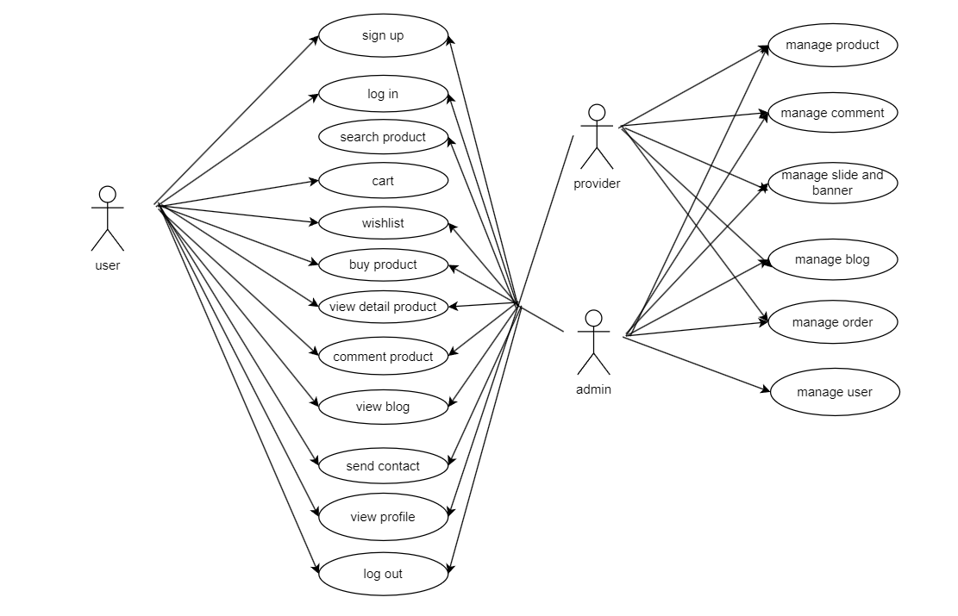

# **Flowchart**

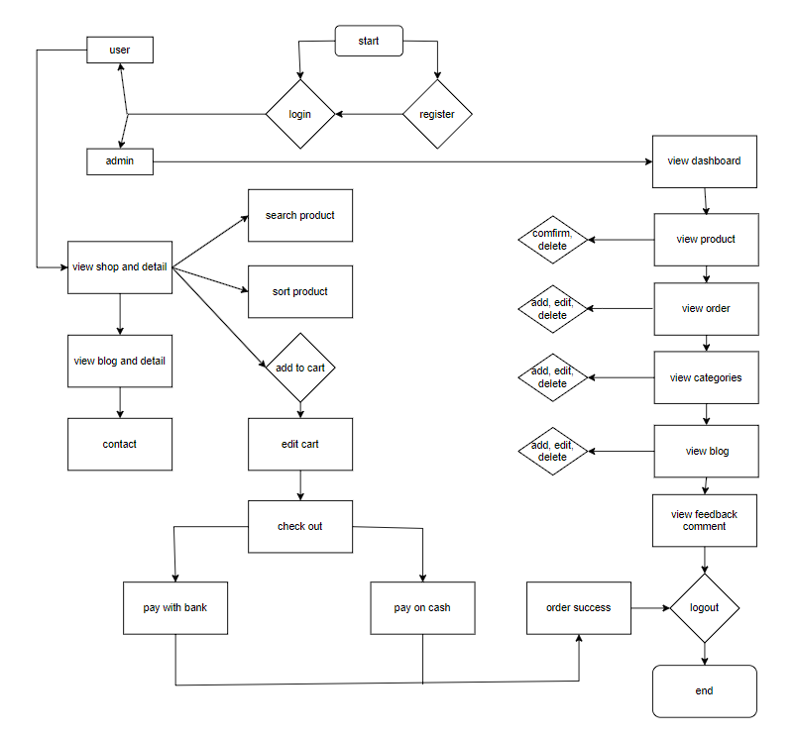

# **Database**

## **DB Relationship Diagram**

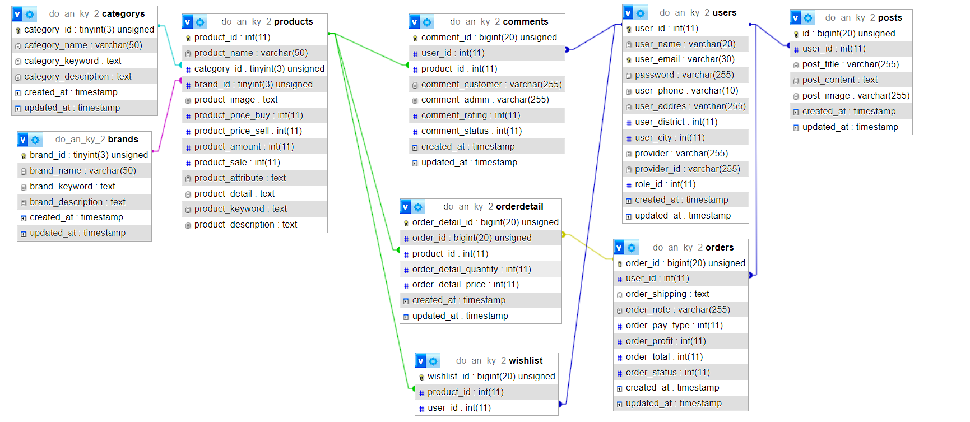

# **UI\UX**

## **User UI**

## **5.1.1 Page register & login**:

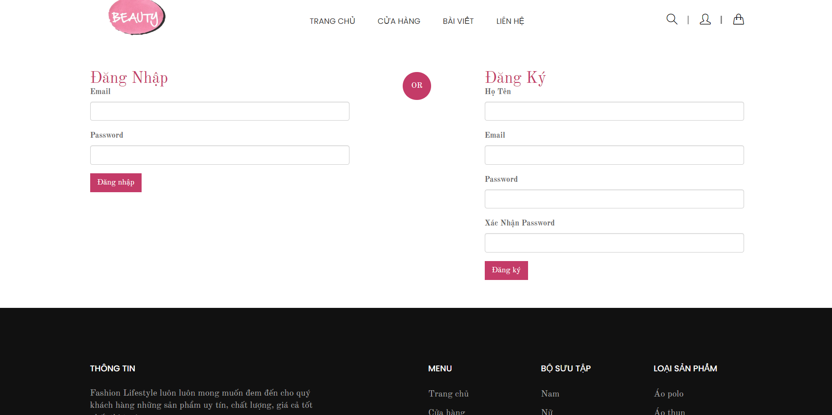

## **5.1.2 Page home**:

**5.1.2.1 Page home**:

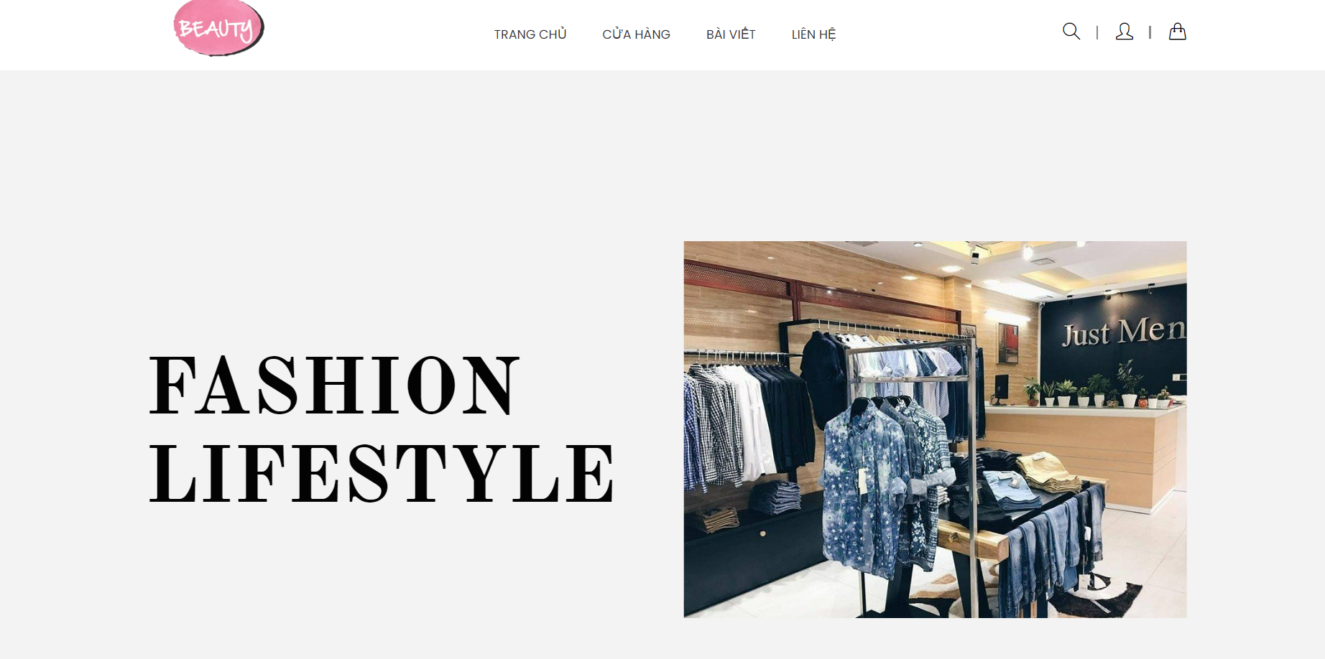

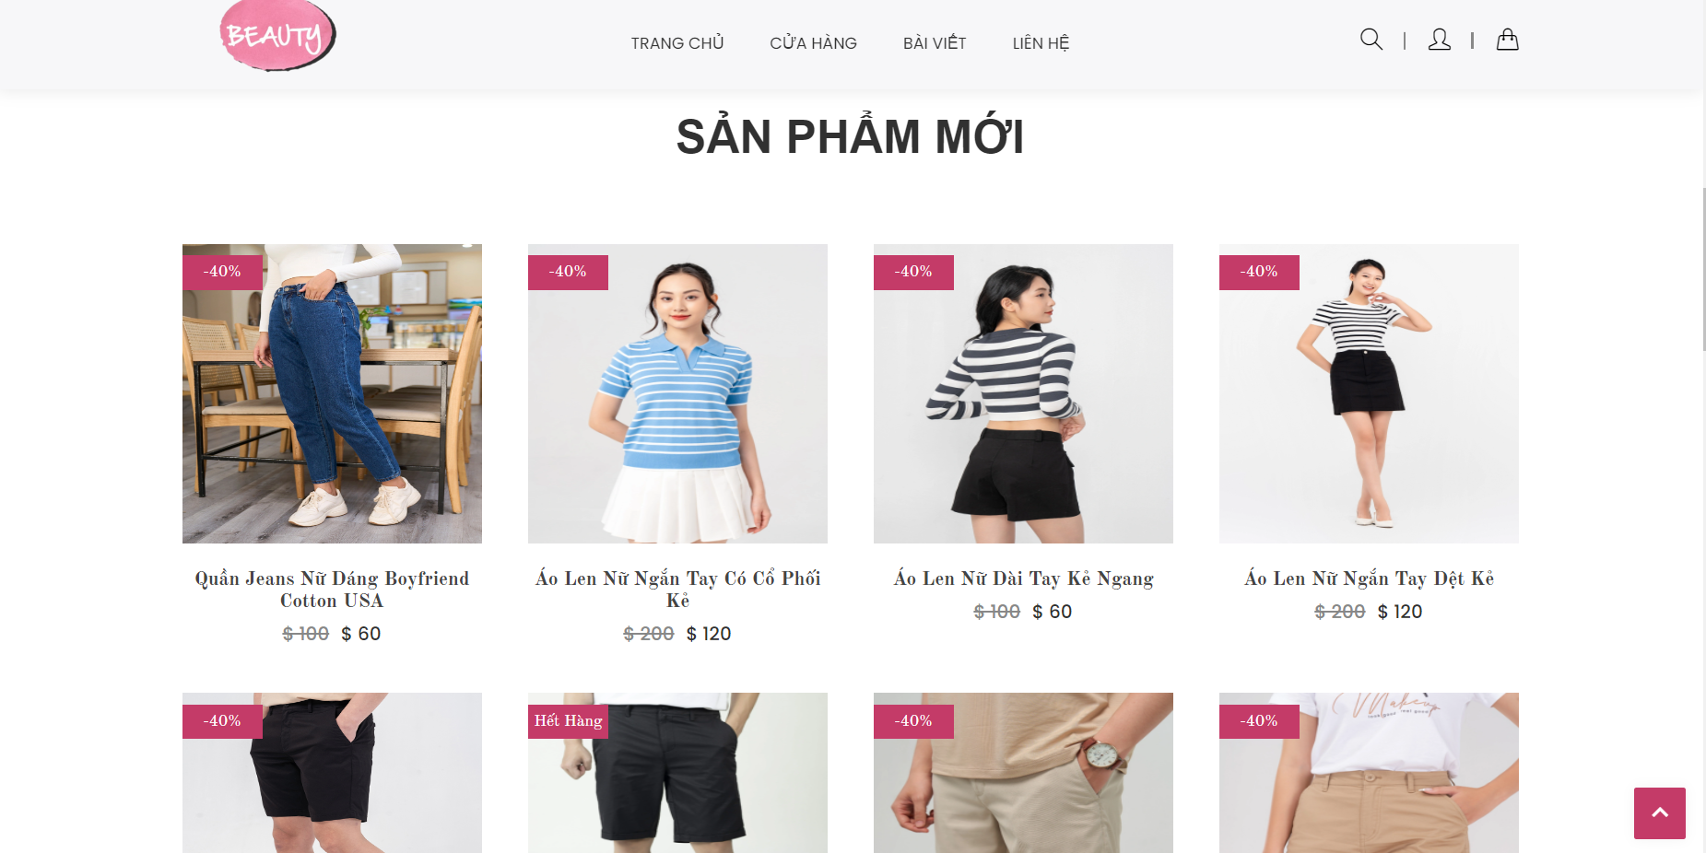

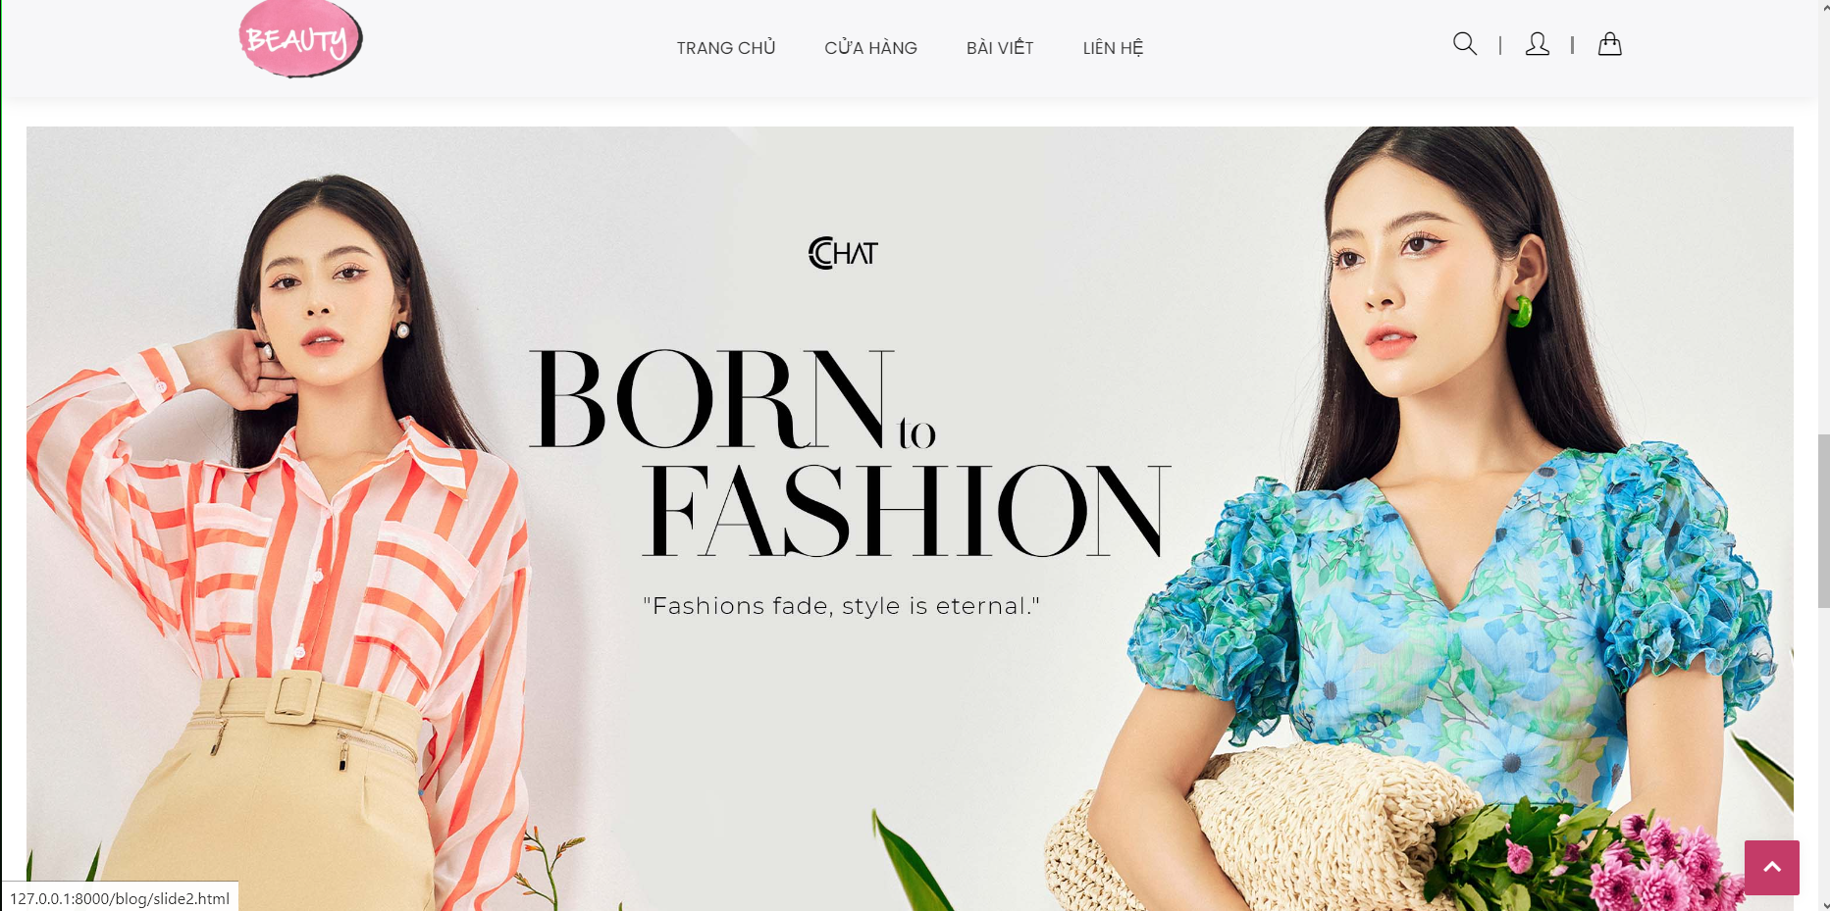

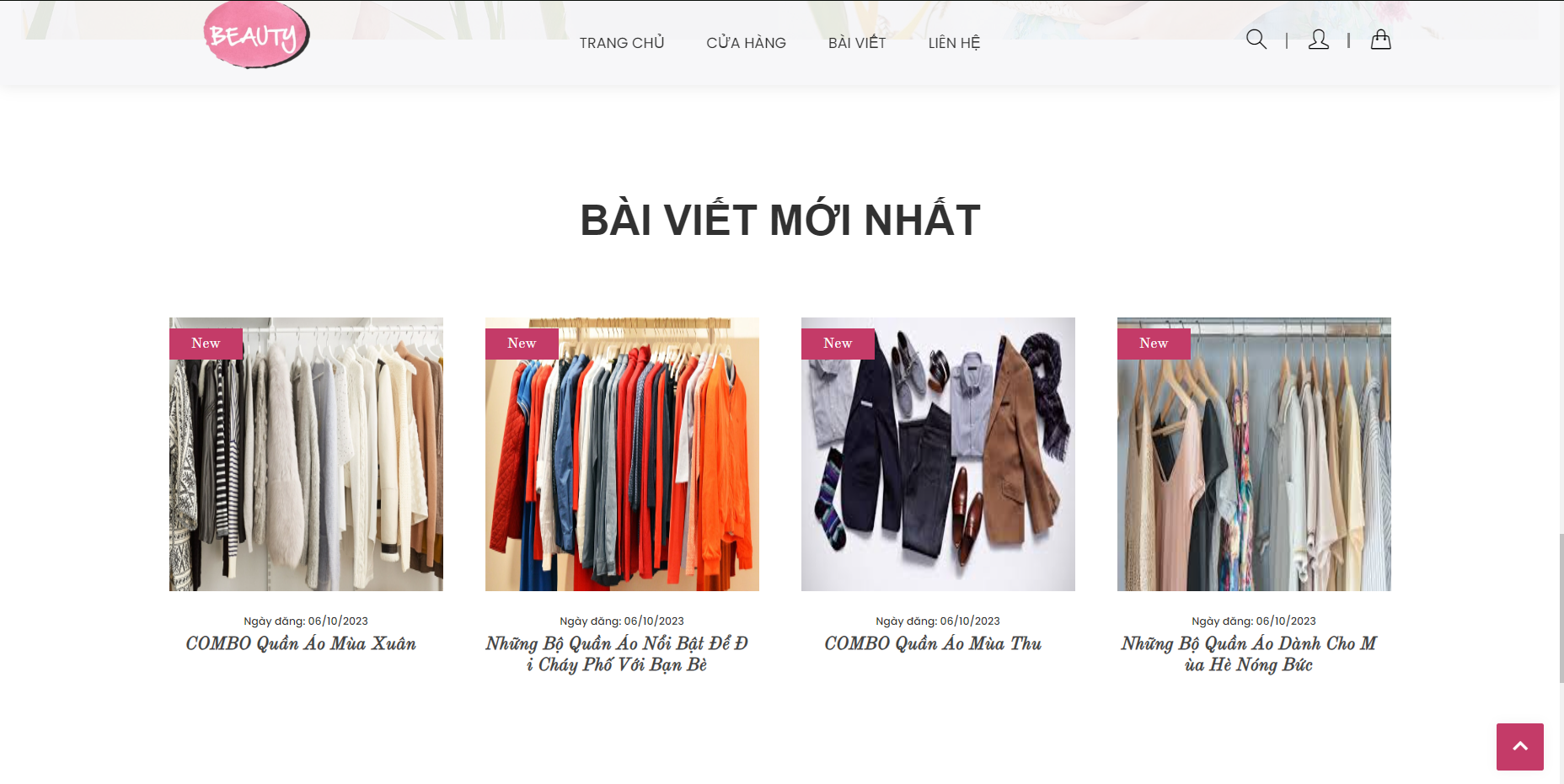

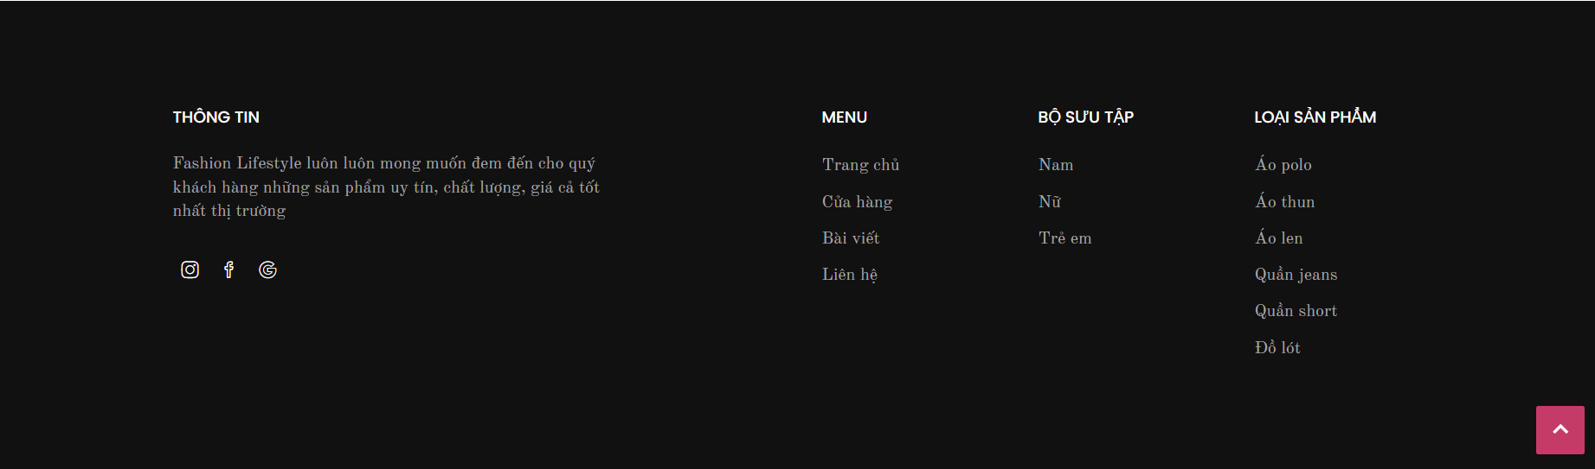

## **5.1.4 Page shop**:

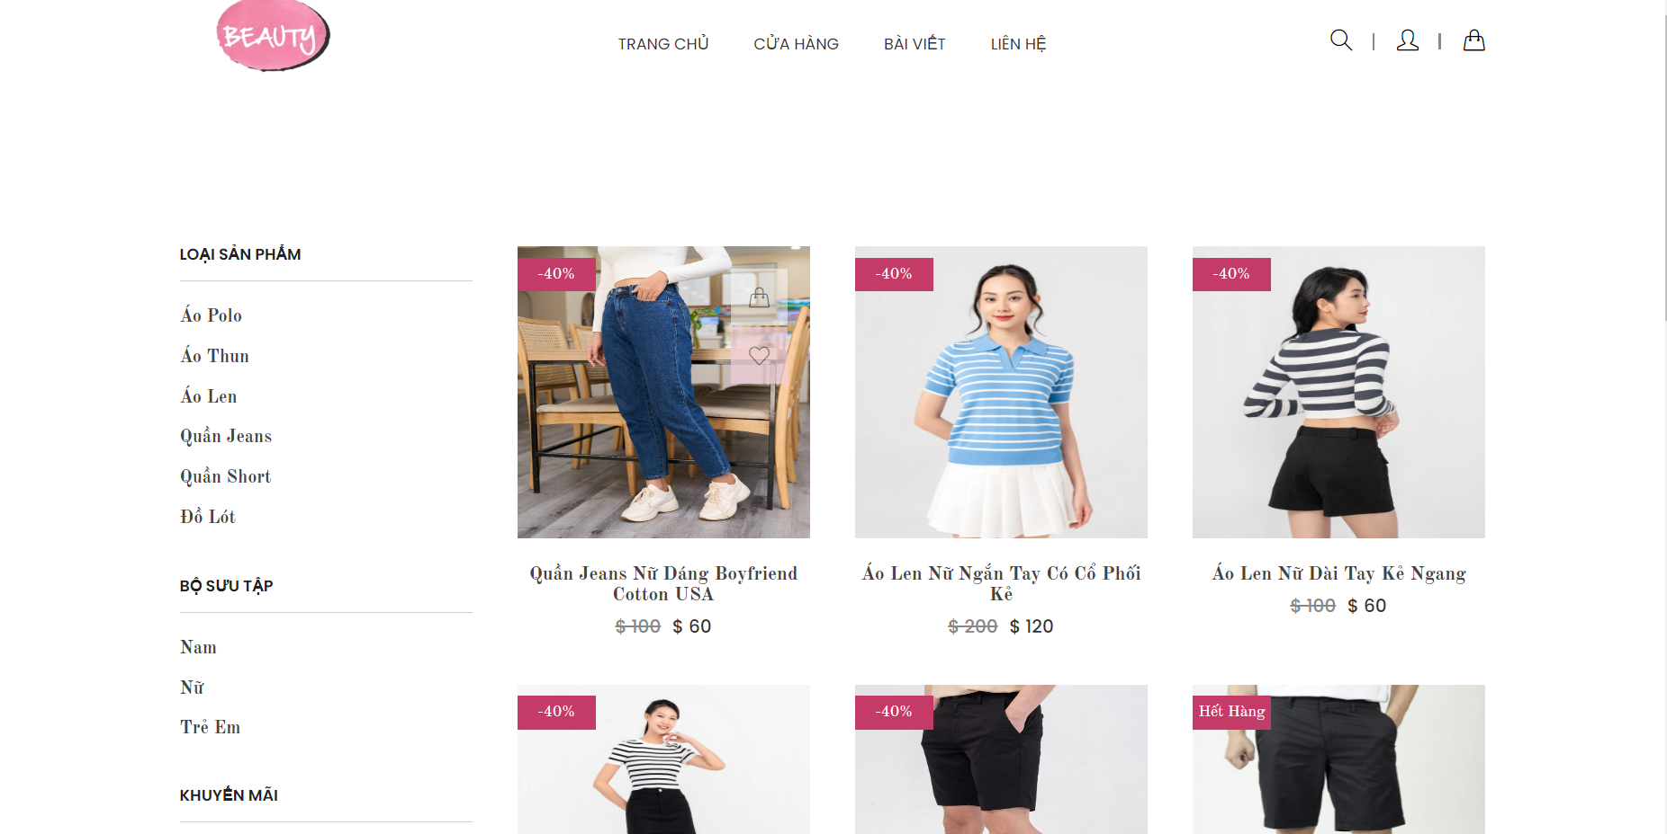

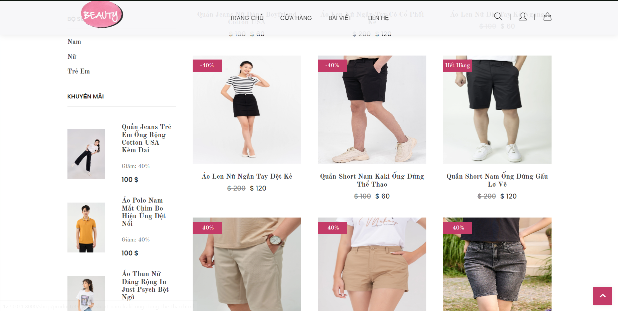

**5.1.4.1 Page shop detail**:

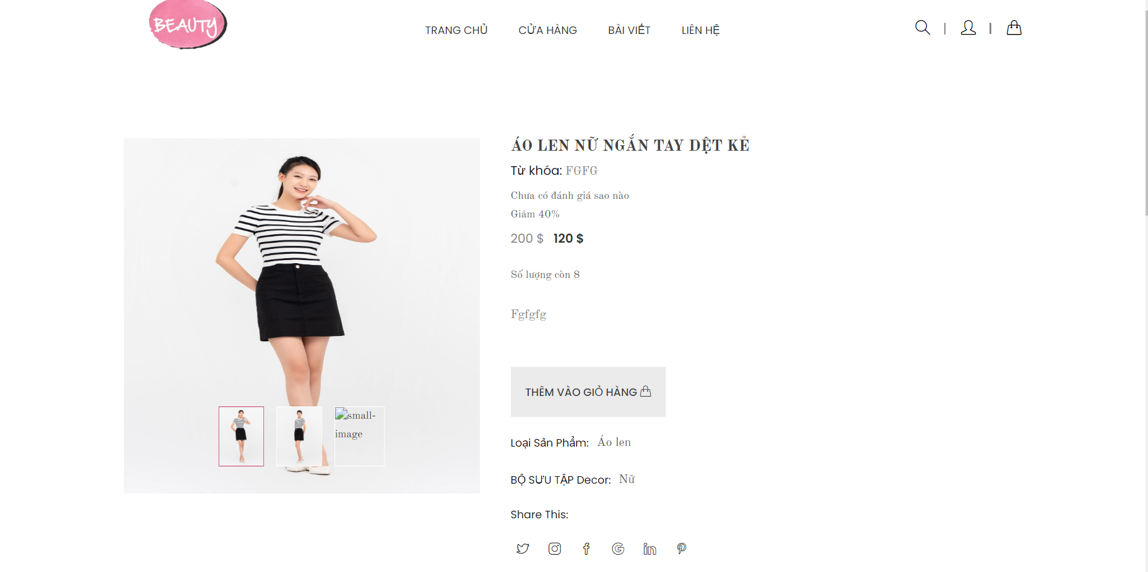

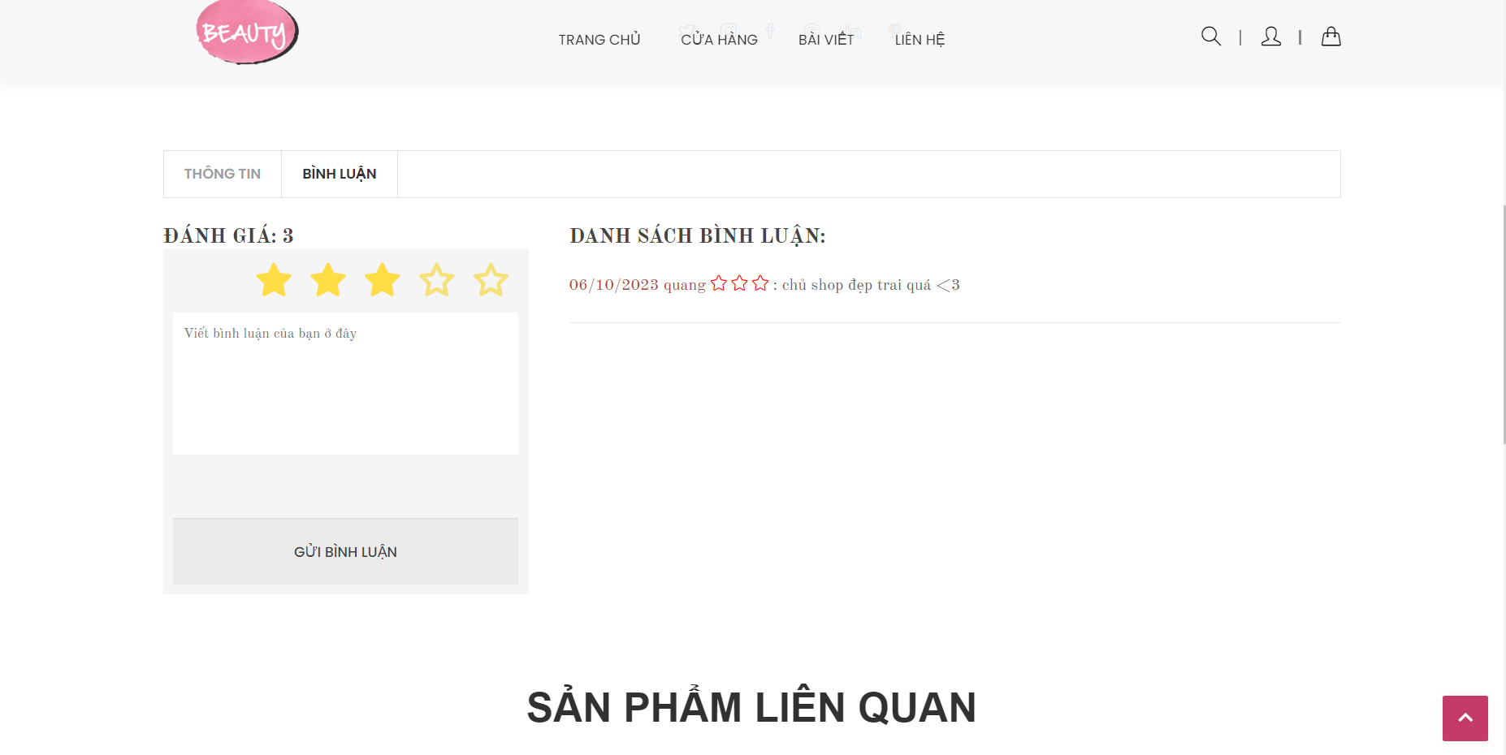

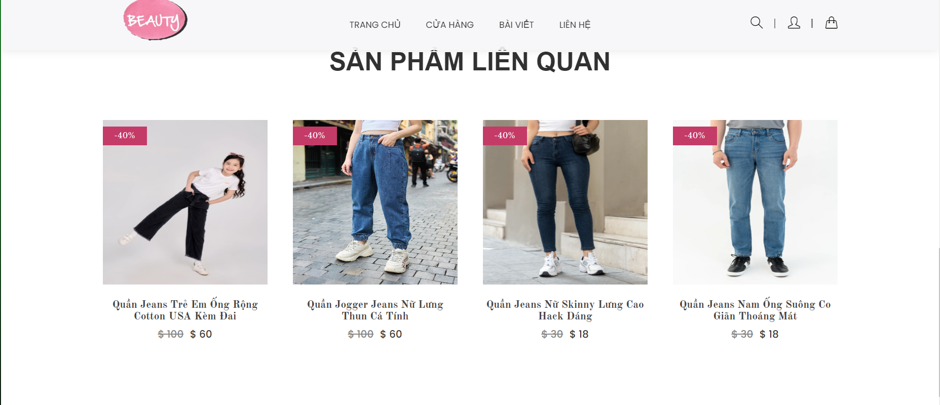

## **5.1.5 Page blog**:

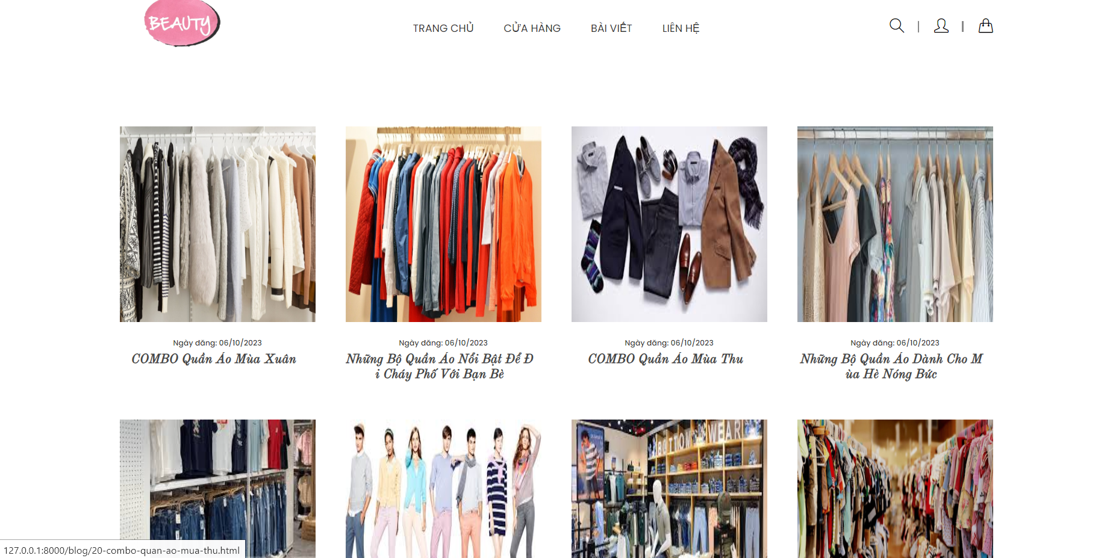

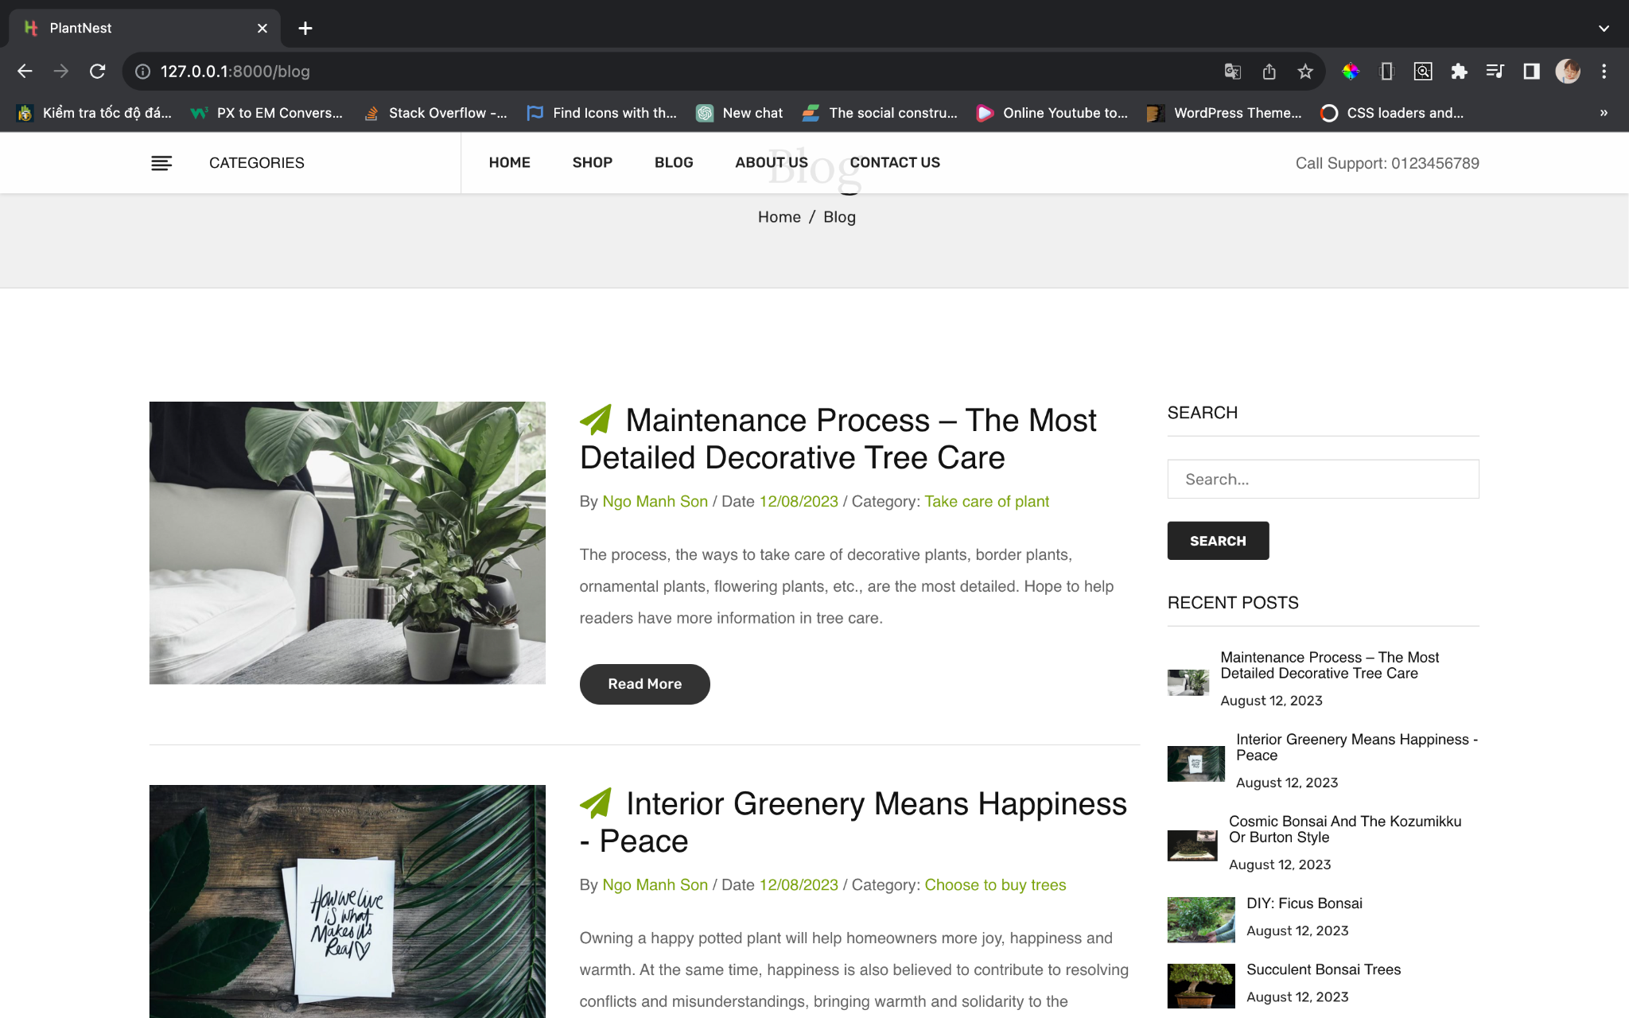

**5.1.5.1 Page blog detail**:

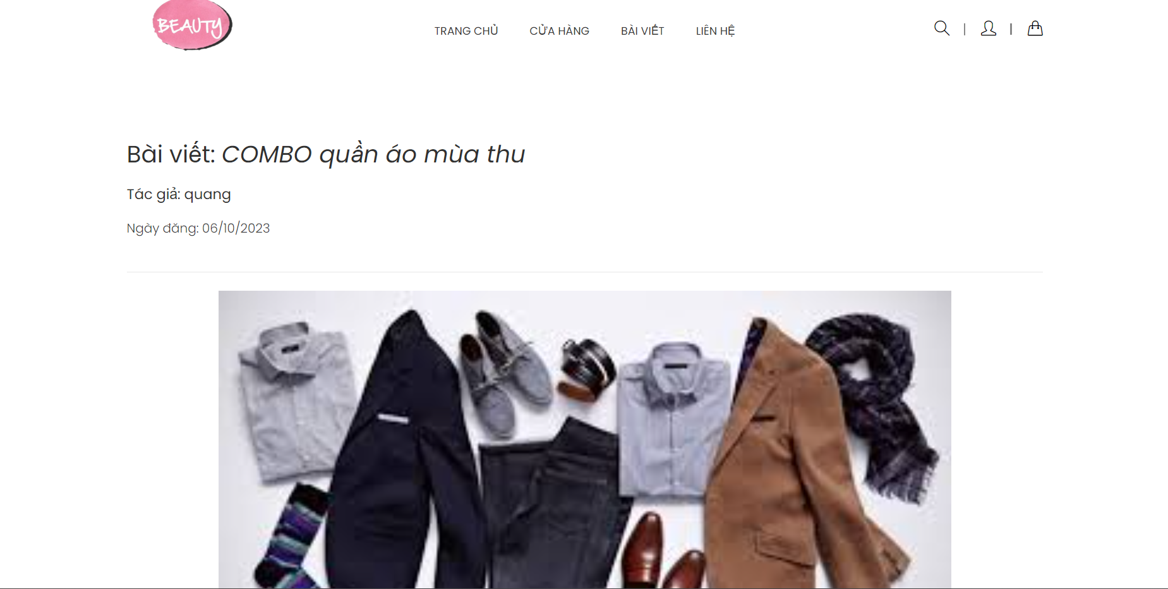

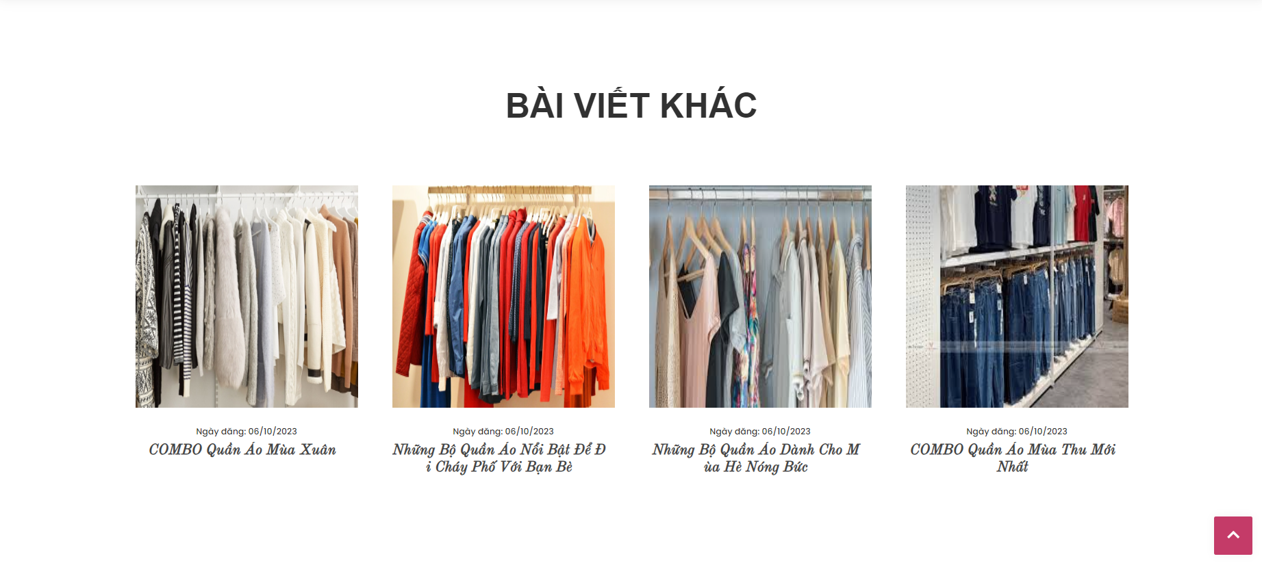

## **5.1.7 Page Contact US**:

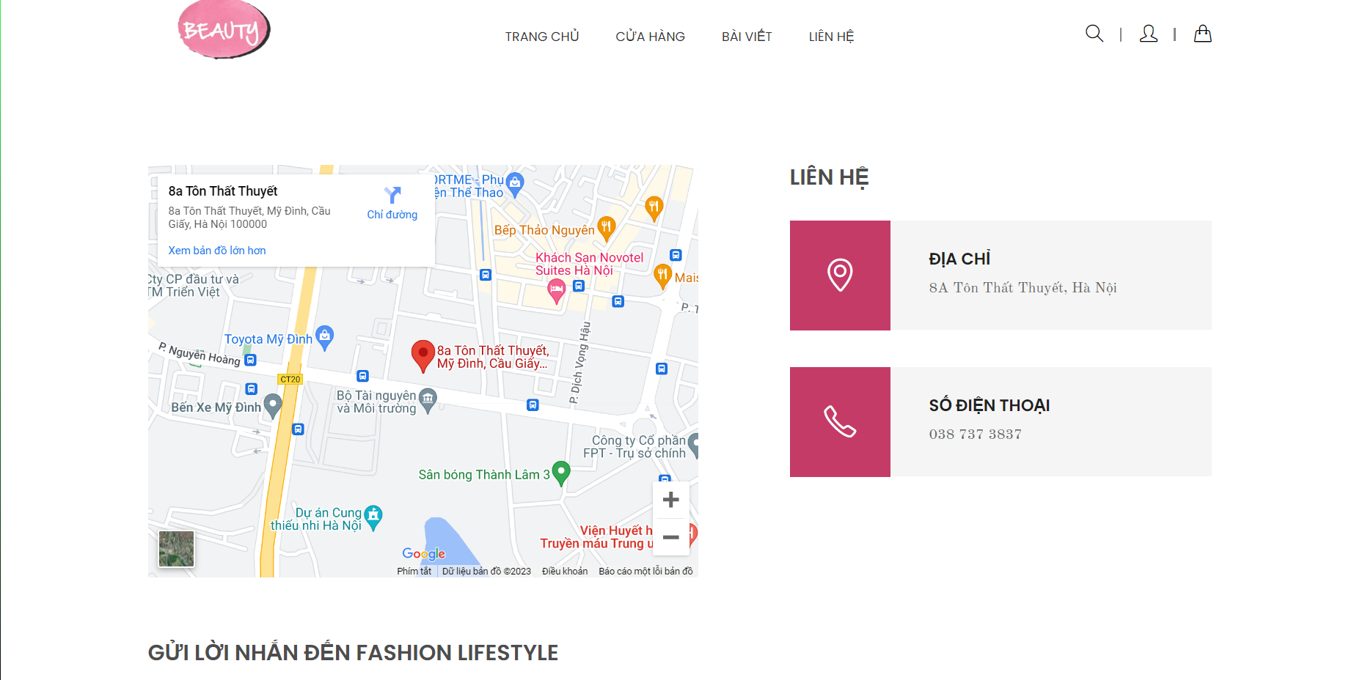

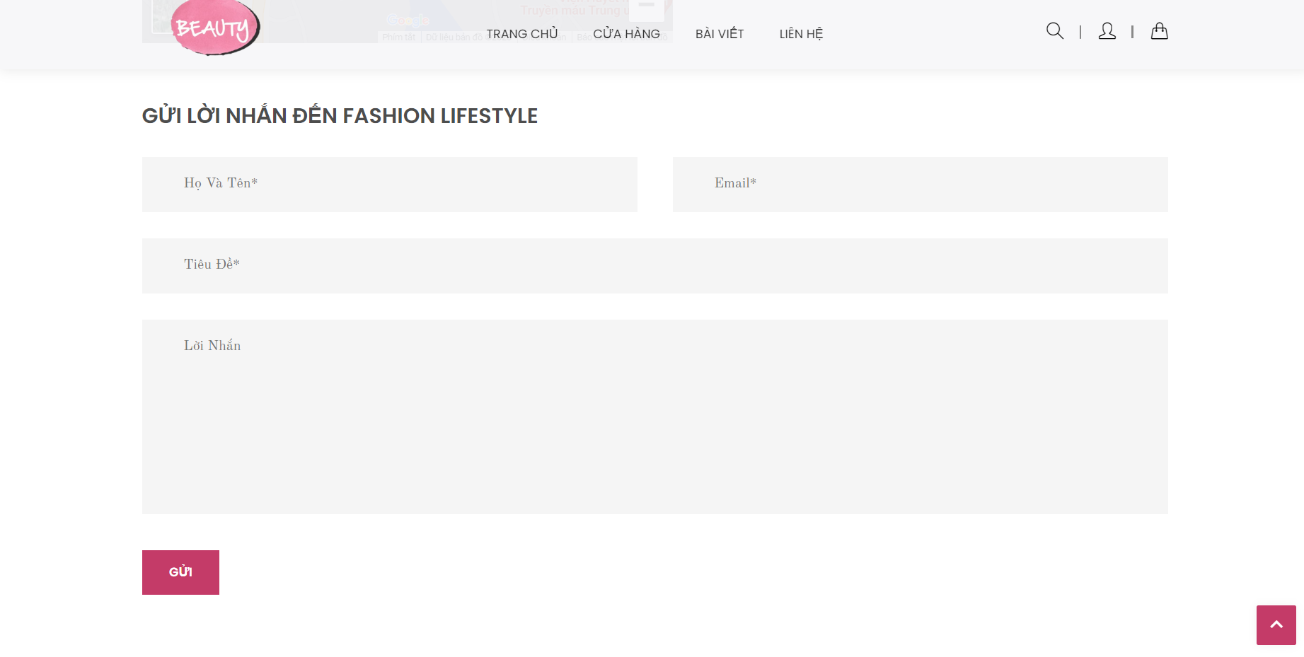

## **5.1.8 Page Cart**:

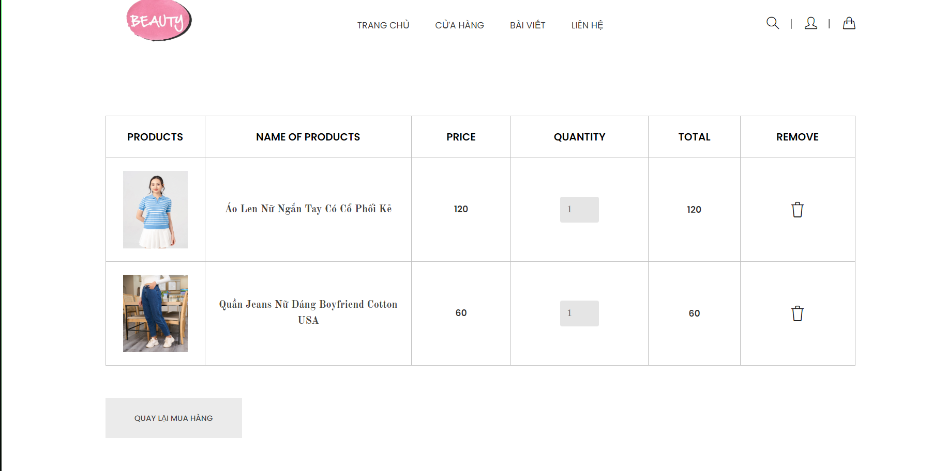

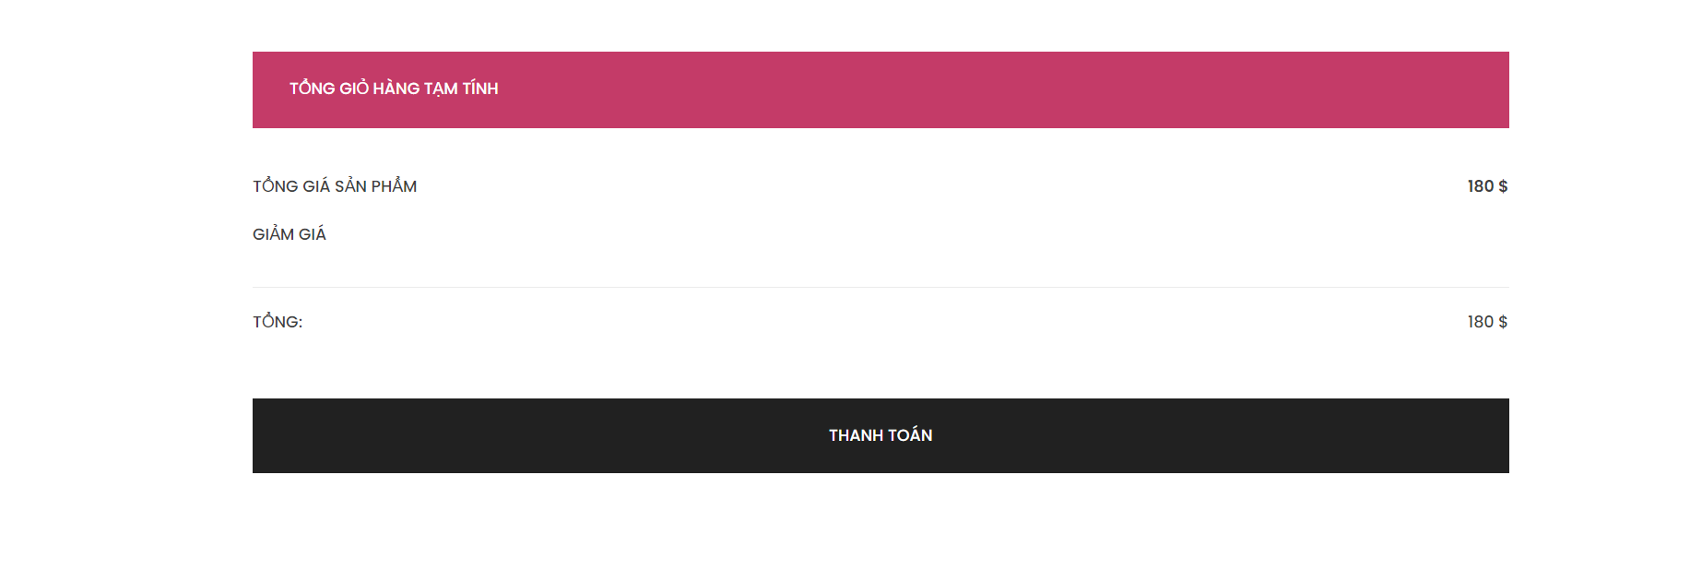

## **5.1.9 Page Checkout**:

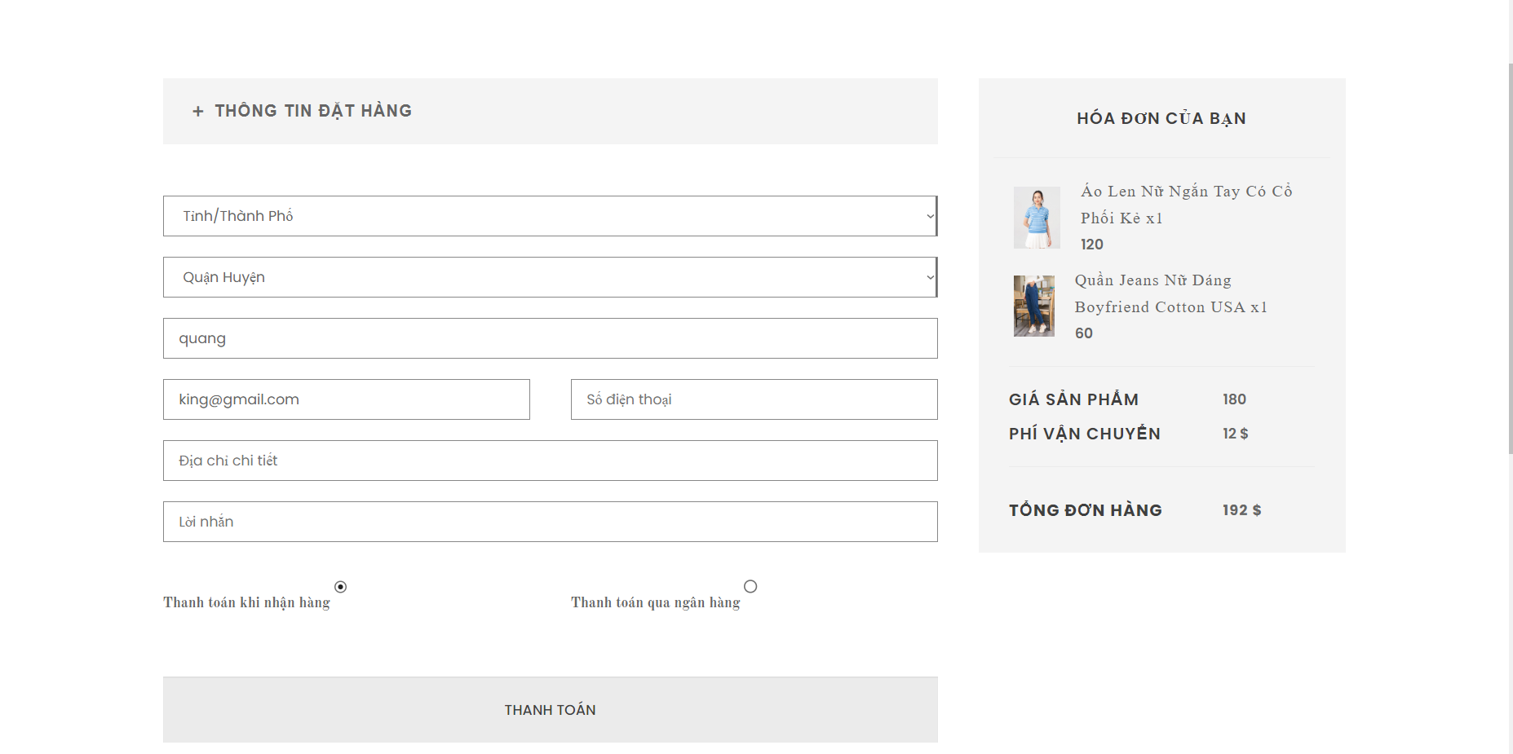

## **5.1.10 Page Wishlist**:

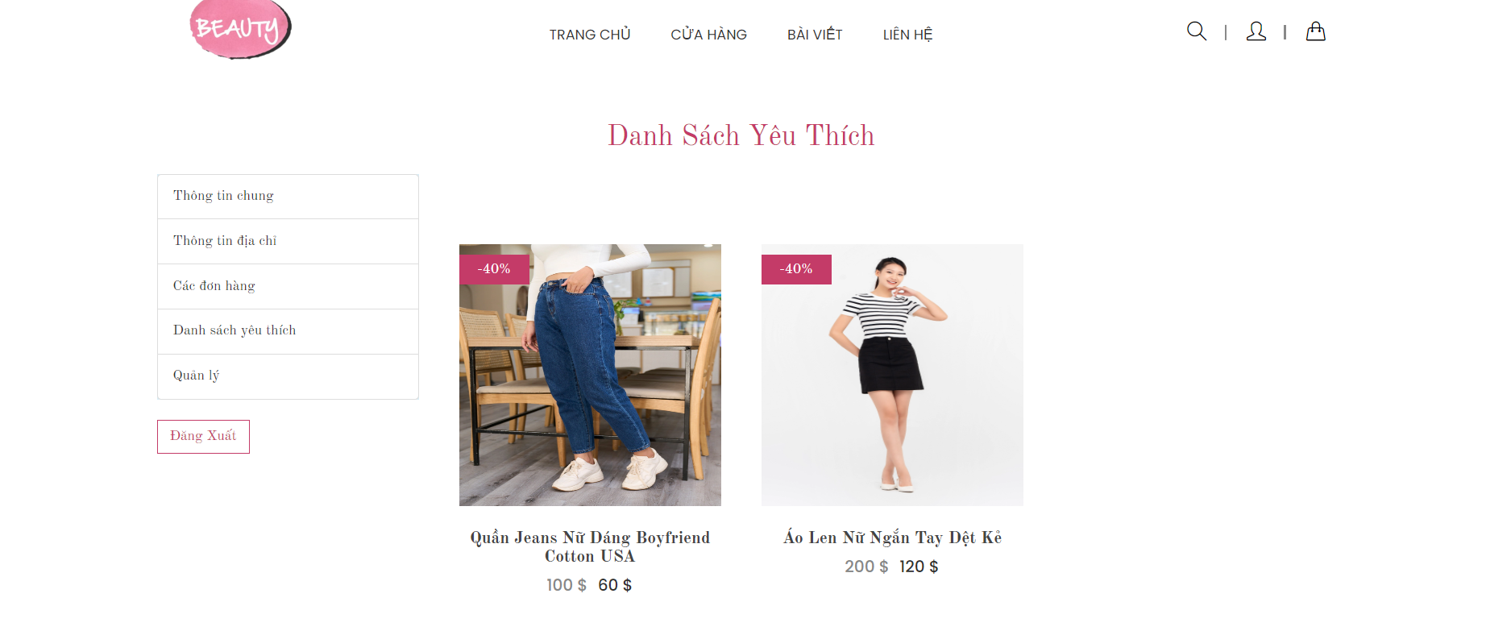

## **5.1.11 Page Account**:

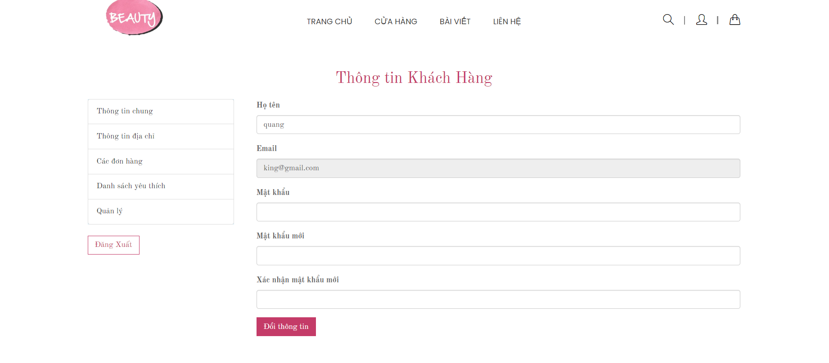

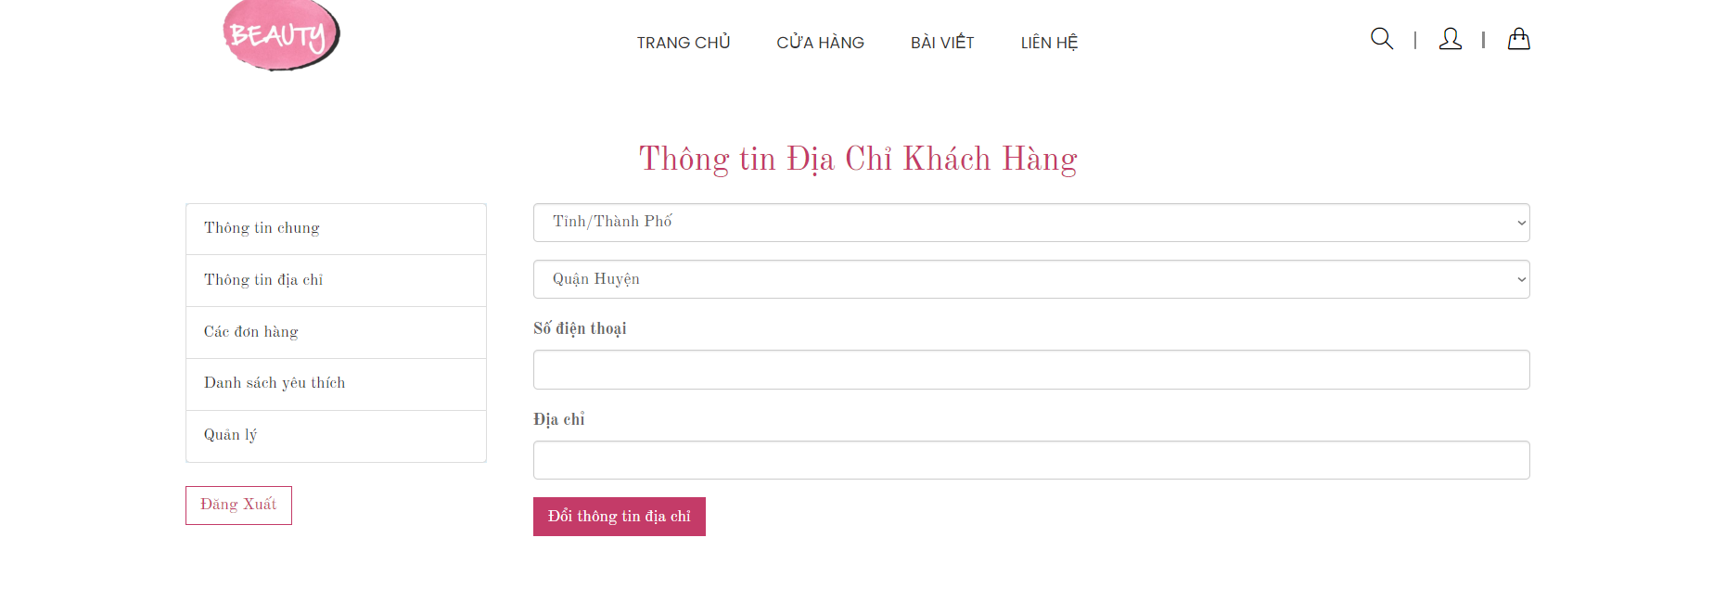

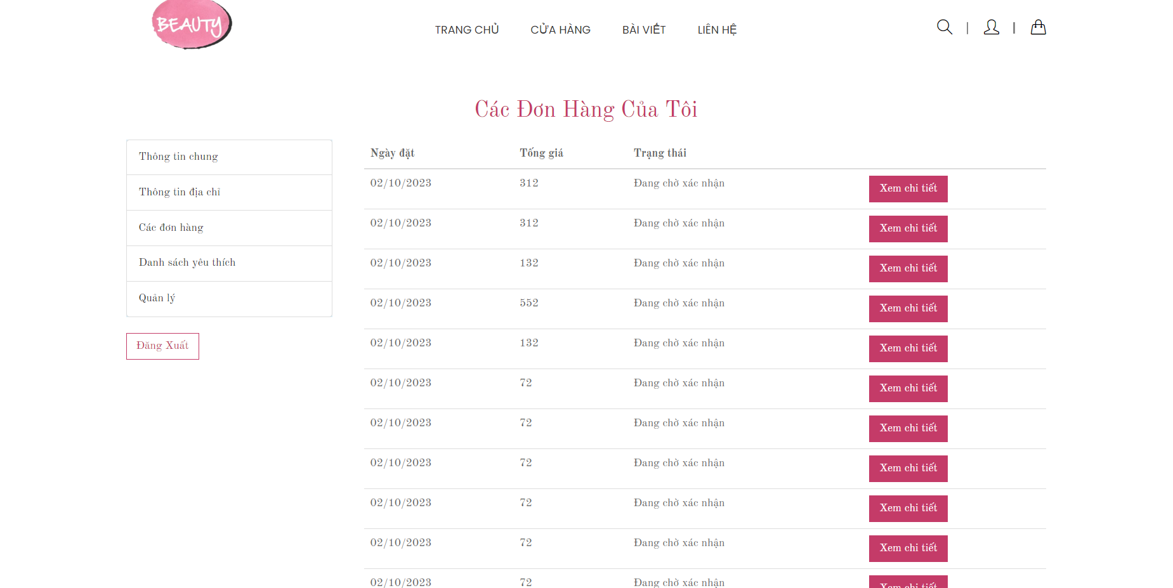

## **ADMIN UI**

## **5.2.1 Page Login**:

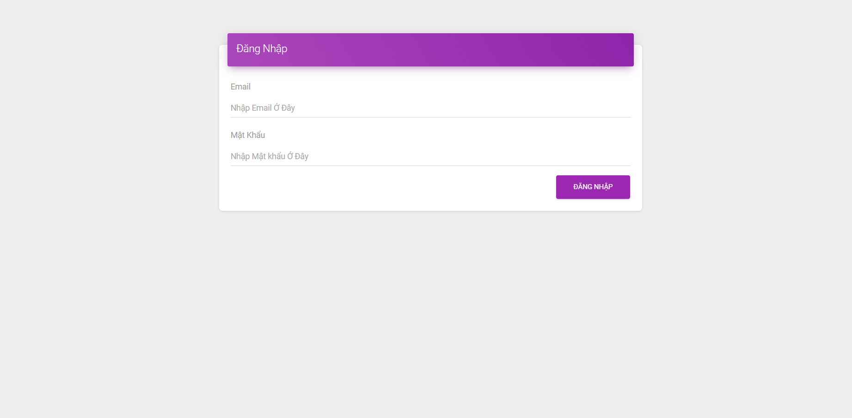

## **5.2.2 Page Dashboard**:

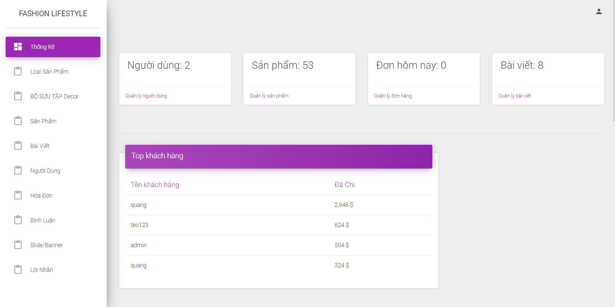

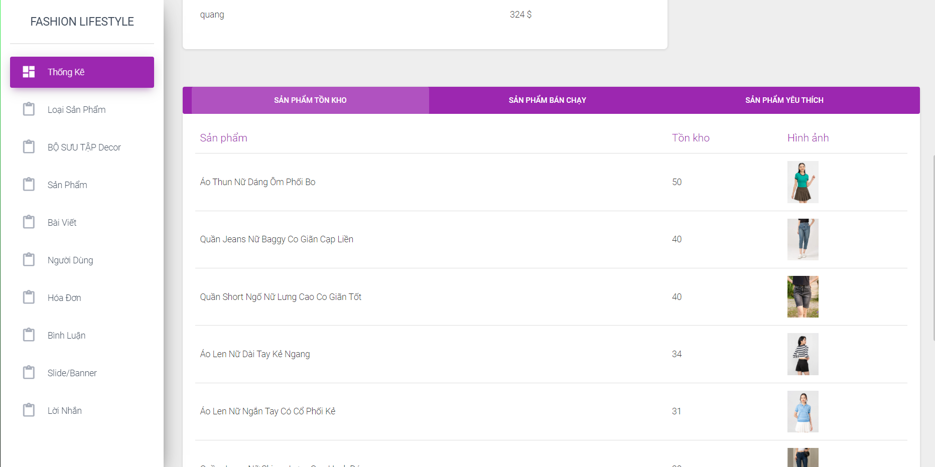

## **5.2.3 Page User**:

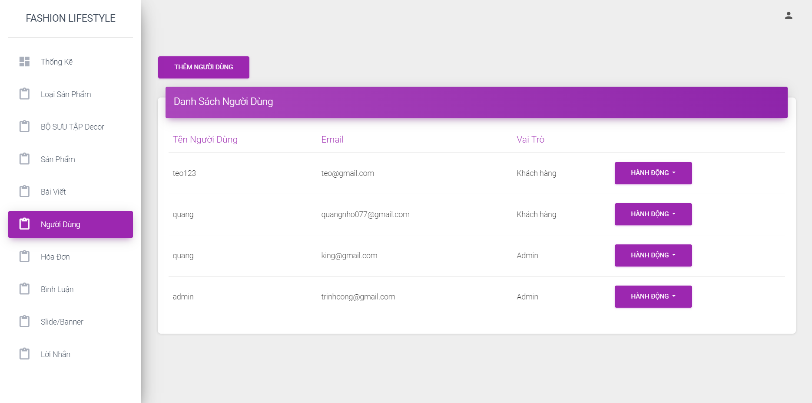

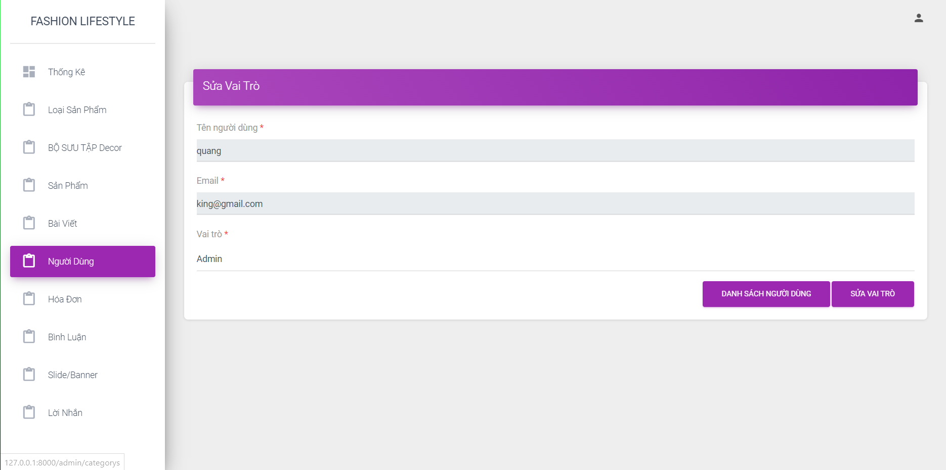

## **5.2.4 Page Orders**:

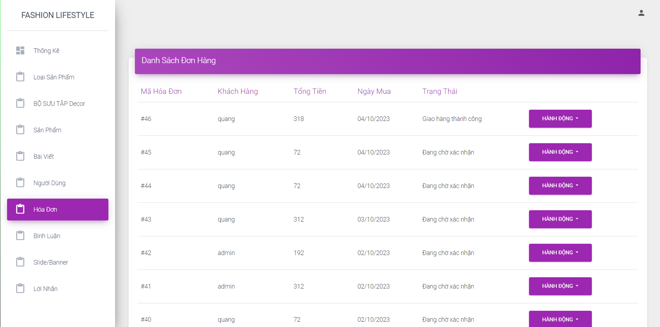

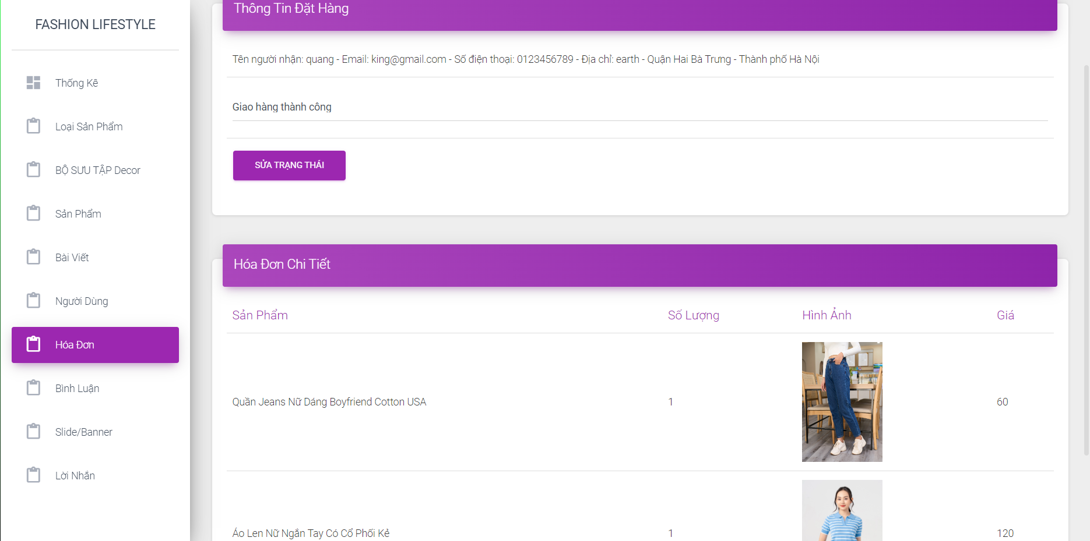

## **5.2.5 Page Product**:

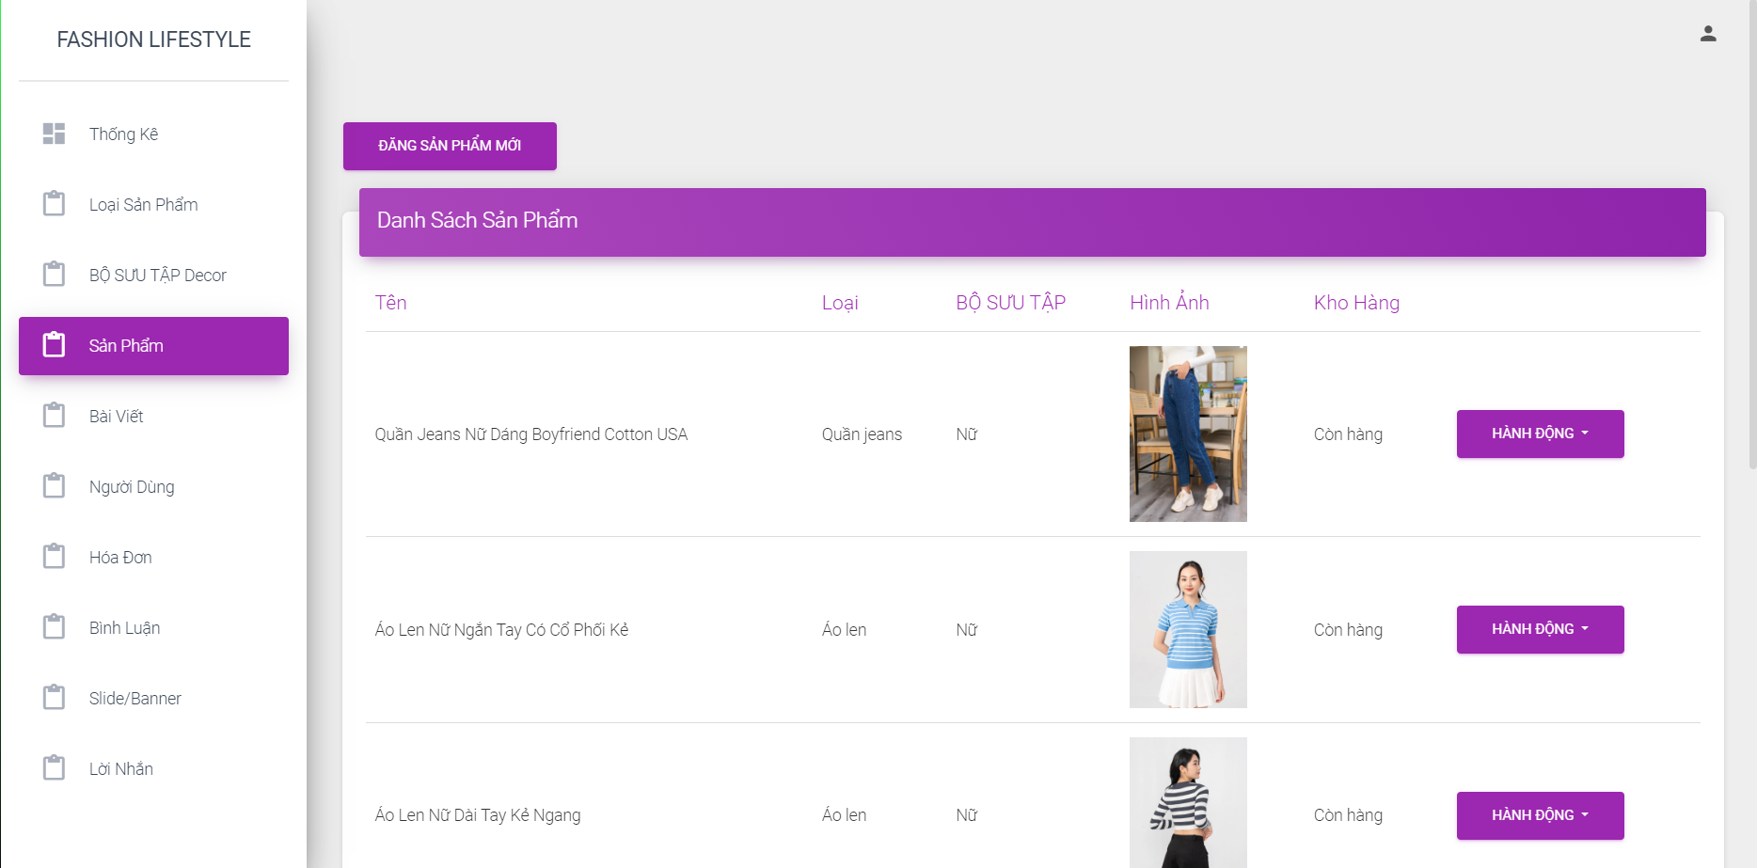

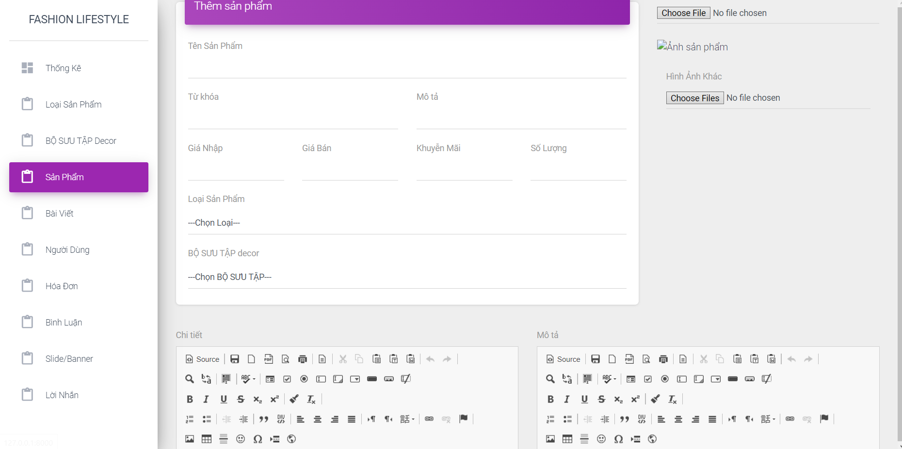

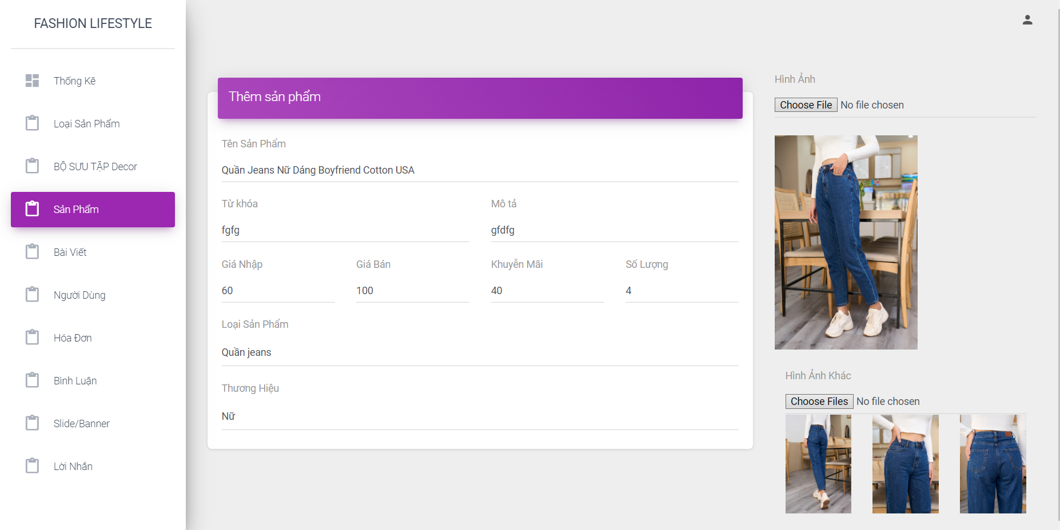



## **5.2.6 Page Category**:

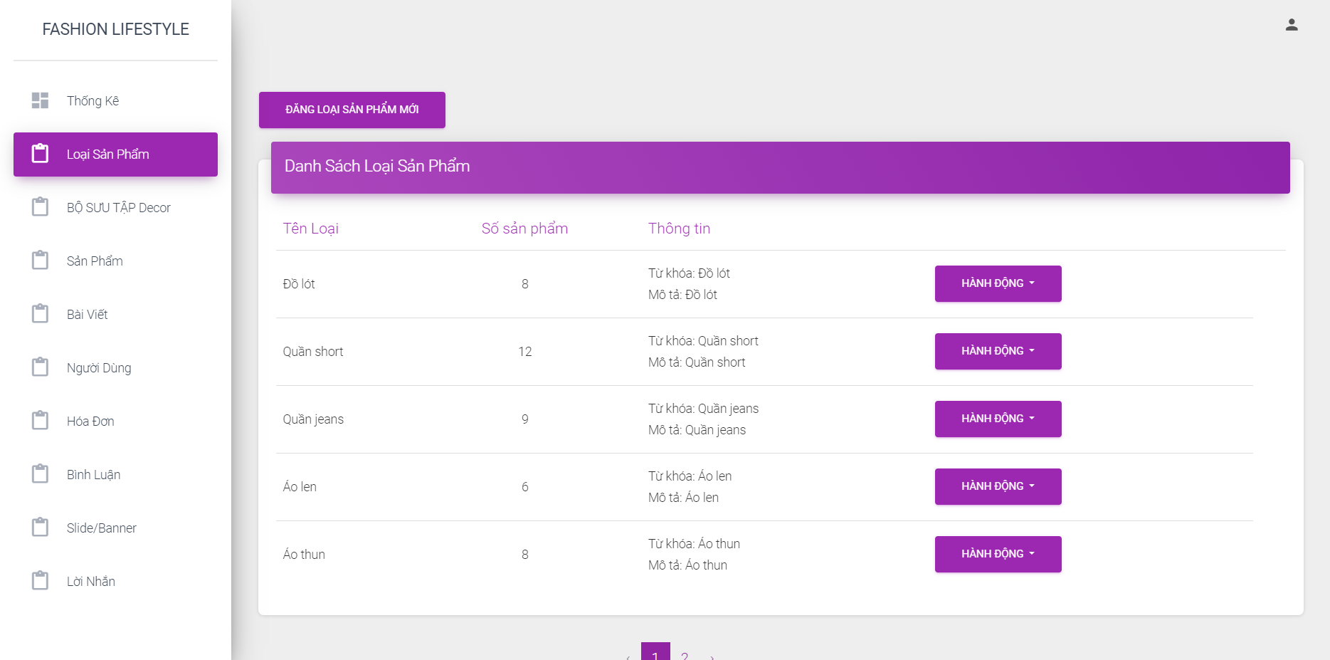

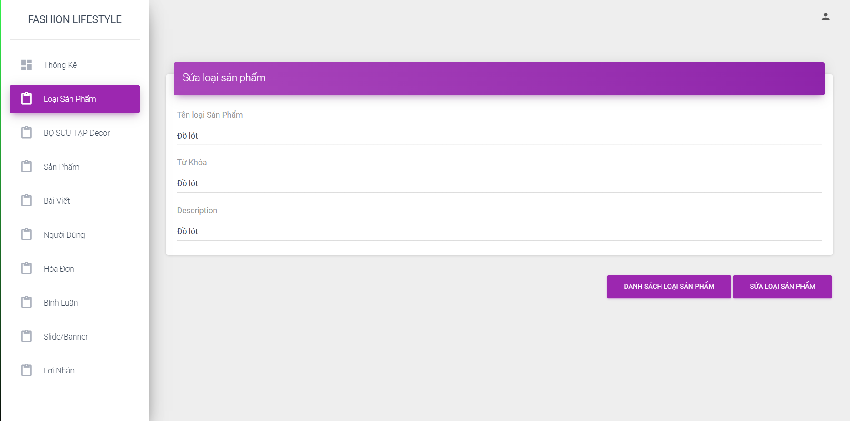

## **5.2.7 Page Blog**:

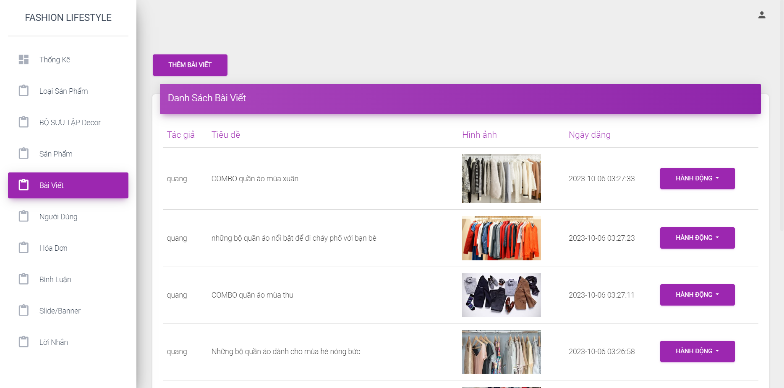

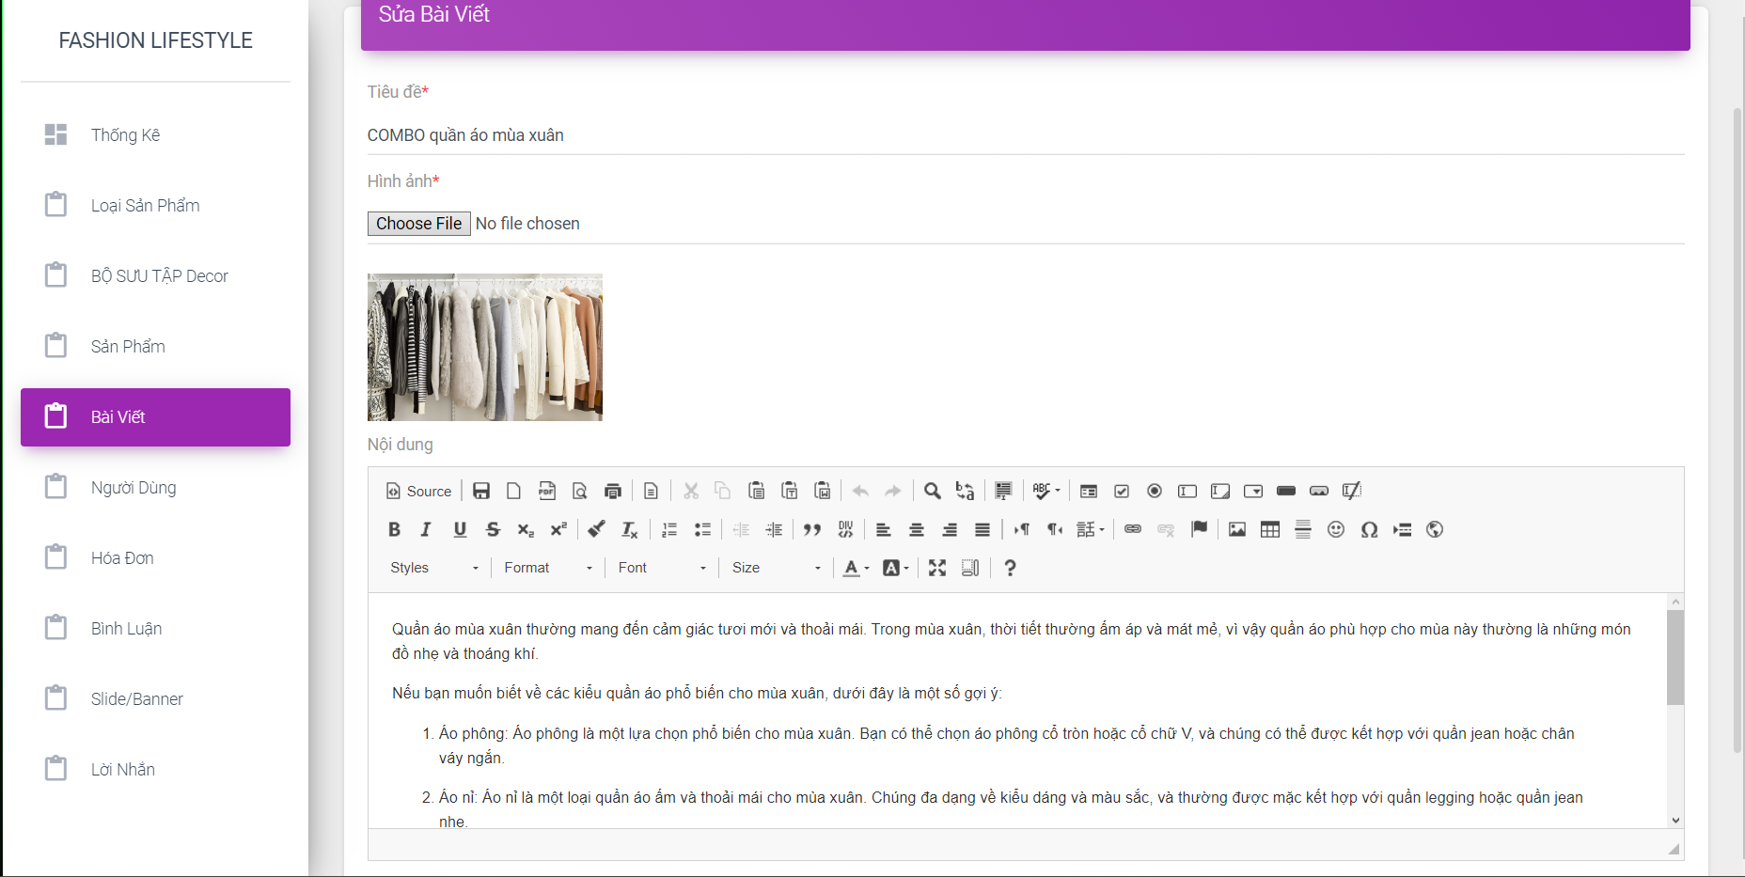

## **5.2.8 Page Feedback**:

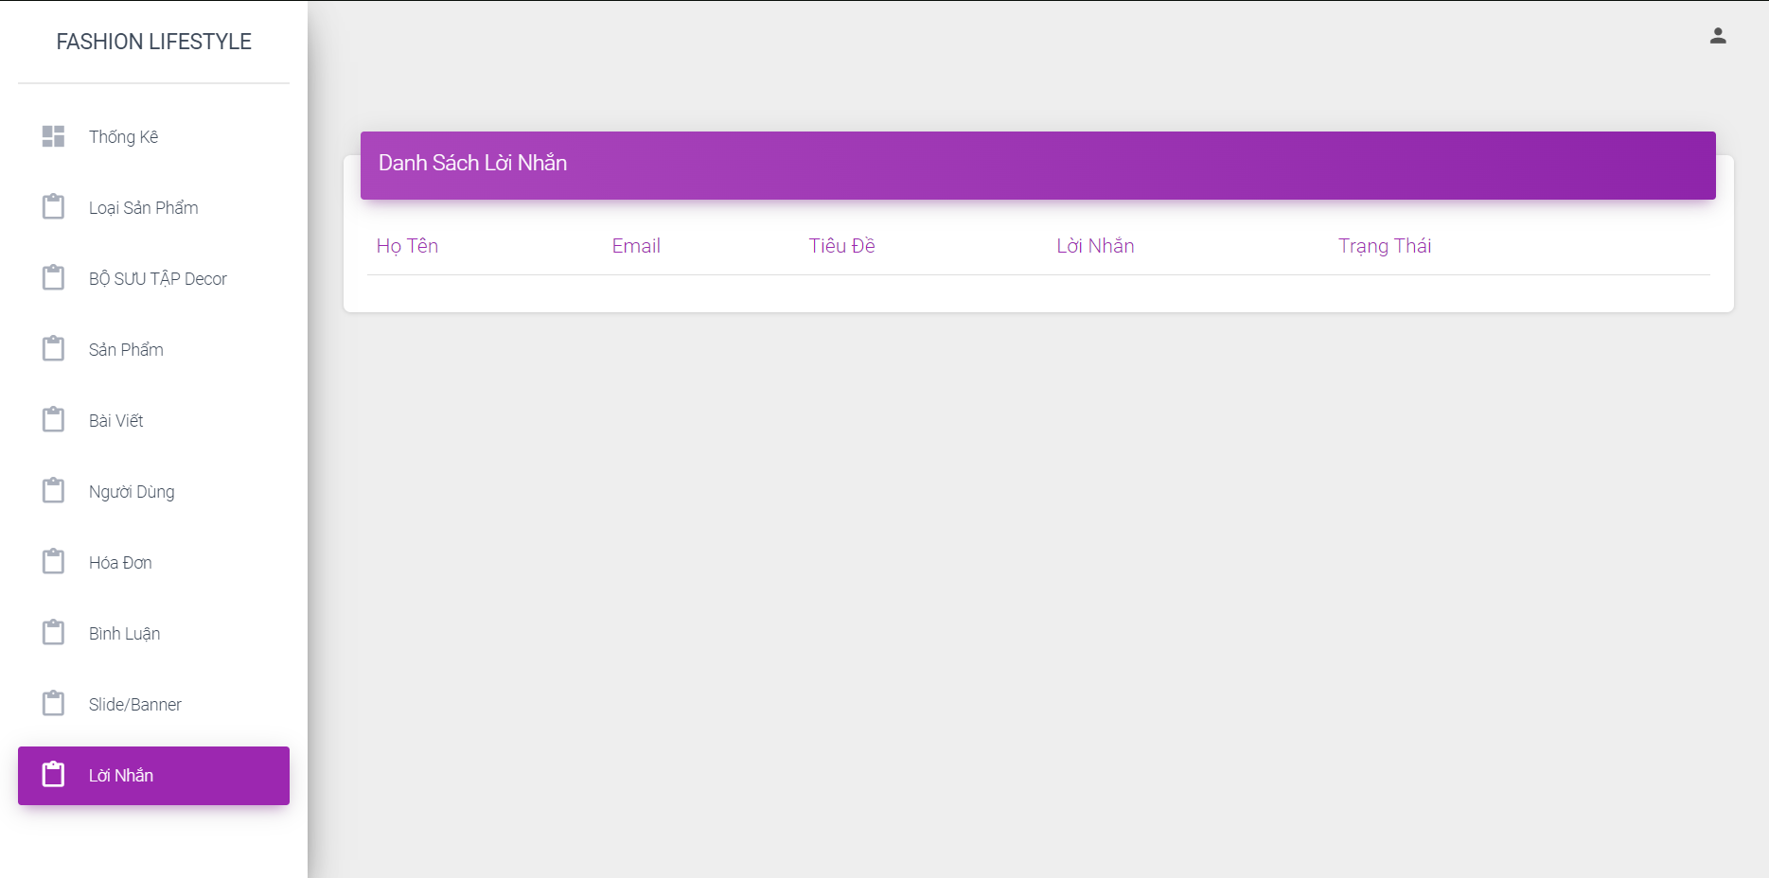

## **5.2.9 Page Review**:

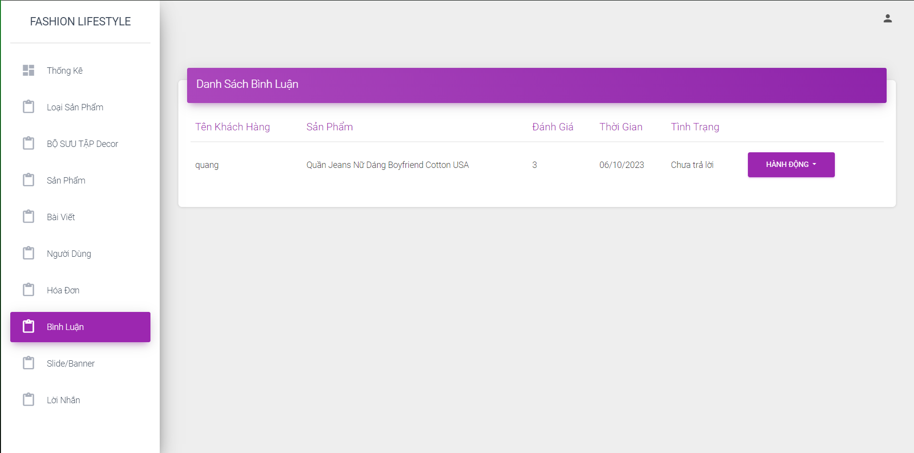

# **Summary**

Our clothing selling website is designed with many useful functions such as searching and filtering products, secure payment and convenient order management. The user interface is user-friendly and product images are arranged in a logical manner, creating an easy-to-use and engaging shopping experience.

The future prospects and development of the project are very promising. We have devised a plan to enhance user experience, enhance marketing and expand the scale of operations. We believe that there will be many opportunities to develop and bring business benefits to website owners.